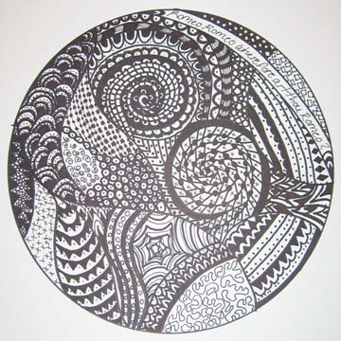
What is Zentangle?

Zentangle is an easy to learn method of creating beautiful images from repetitive patterns. It is a fascinating new art form that is fun and relaxing. It increases focus and creativity. Zentangle provides artistic satisfaction and an increased sense of personal well being. Zentangle is enjoyed by a wide range of skills and ages and is used in many fields of interest.
Characteristics of Zentangle
Intuitive Art form
With Zentangle, anyone can create beautiful images from repetitive patterns. This method is easy to learn and easy to do. And even though it is a specified series of steps, it results in a creative expression that transcends its own rules
Abstract
You cannot fail to create a Zentangle. That is because a Zentangle is meant to look like a Zentangle. It does not need to look like anything else and has no up or down.
Unexpected Results
Zentangle is an unusual approach to art because you have no idea what its result will be when you begin. Your creation is not restricted by your expectations.
Ceremonial
Zentangle is an artistic meditation that supports relaxation, focus and inspiration and can be a wonderful daily ritual. Zentangle's philosophy, symbolism and metaphor is elegant and profound. There is much to discover about life and one's self through this simple act.
Timeless
Creating designs, manipulating symbols and putting pen to paper is part of our human heritage. In a time of keyboards, computer mice, and cell phones, Zentangle allows a return to a comfort and familiarity of timeless, basic creativity.
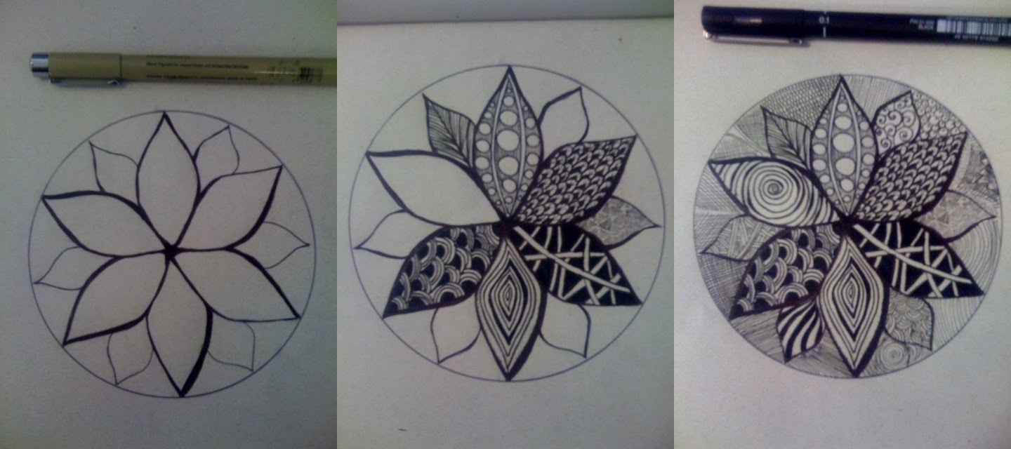

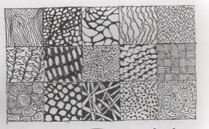

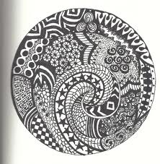
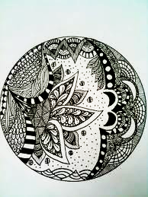

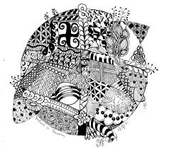

Zentangle Doodle Sheet: 30pt Graded Assignment
In each square, create a different doodle with your sharpie marker. Each design has to be different, but some can be a similar pattern.

