Wet Fold Faces Lesson
Kelly Herman
Art II

Lesson Overview: Students will take a look at wet fold origami and Peter Classan’s cut paper art and create their own wet paper sculpture as part of a drawing lesson.

Essential Questions:
- How to artists embed a message in their artworks
- Who interoperates artwork, the artist or the viewer?

Key Concepts:
- Wet paper folds hold because of the tension on the paper from the water
- Value is used to show shadows and creases in folded paper

Standards:
9.1.12.E: Delineate a unifying theme through the production of a work of art that reflects skills in media processes and techniques.
9.2.12.D: Analyze a work of art from its historical and cultural perspective.
9.4.12.D: Analyze and interpret a philosophical position identified in works in the arts and humanities.

Materials: Heavy brown paper, sponges, water or spray bottle, clothes pins, hairdryers, drawing paper, pencil, colored pencil

Procedures:
- Day 1: Students will take a look at the artwork of Akira Yoshizawa and Peter Callesen and how they utilized something as fragile as paper to create their artworks. Students will then be instructed to experiment with the wet paper fold technique to create a face
  - By damping the paper with a sponge, it will give it just enough moisture to not be sopping wet
  - Pinching and folding the paper will create creases. Hold areas that need to be pinched with a paperclip
  - Dry with hairdryer to hold folds, or overnight, remove strips

- Day 2-4:
  - Students will use scissors if they would like to make cuts into their artwork
  - Arrange the face paper sculpture in a way that you can look at it to draw.
  - Fold a piece of drawing paper in half, and draw just the CONTOUR lines that you see on one side. Fold the drawing and rub your pencil to transfer the same lines to the other half. You should have two drawings
  - Shade one side with pencil and one side with colored pencil. Use value to start dark in the crease areas and light as you go outward
- Review and Critique
  - Choose an artwork by Peter Callesen or Akira Yoshizawa
    - Choose a card and answer the critique questions on the card in writing
    - Compare your work to the professional artists, what was different or the same in your process and your conception.

http://www.webdesignerdepot.com/2009/05/100-extraordinary-examples-of-paper-art/

http://www.youtube.com/watch?v=yaU0Xg8SHfA

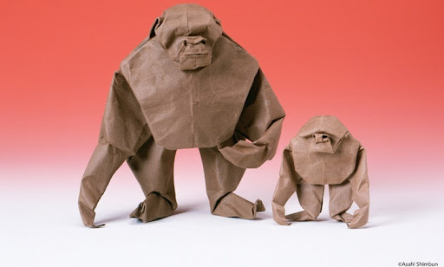
Akira Yoshizawa
Gorilla Family

Peter Callesen
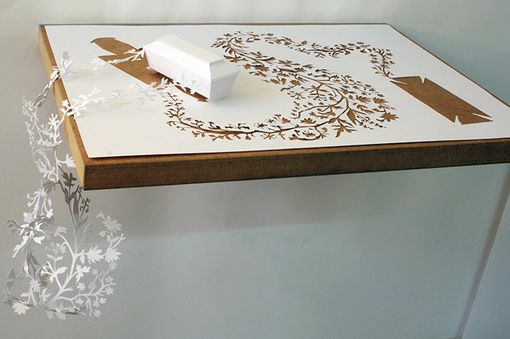

Peter Callesen
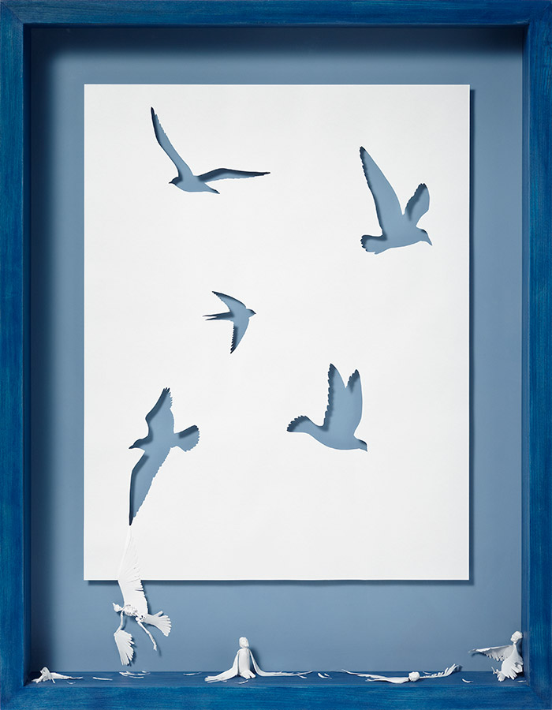

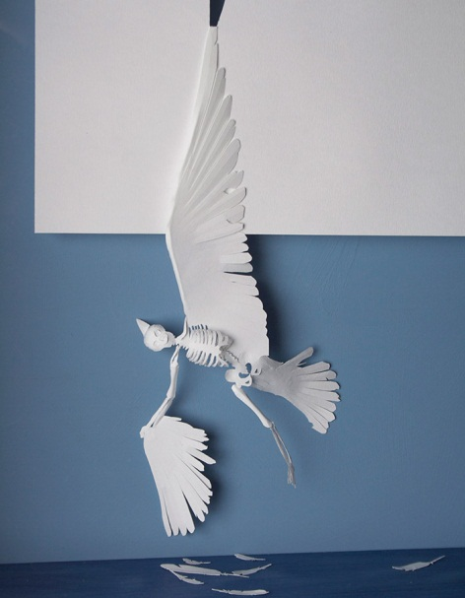
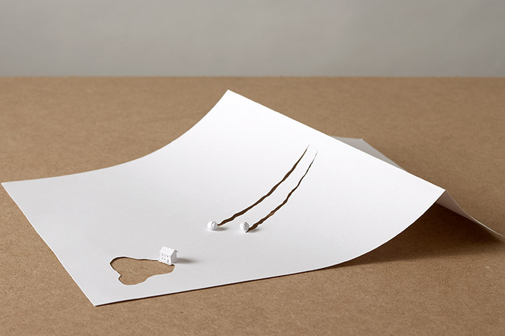

Peter Callesen
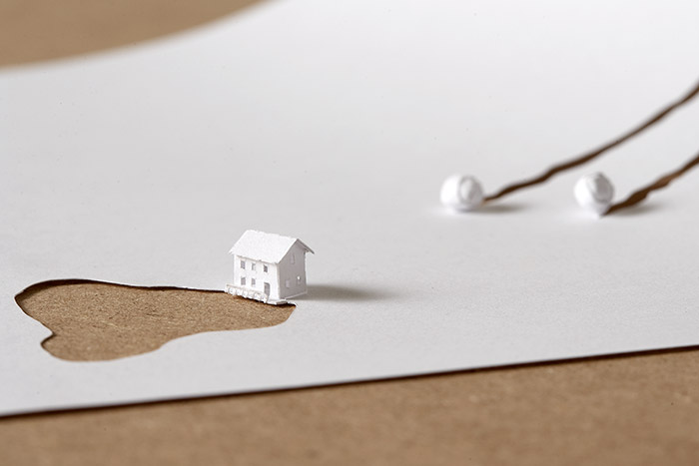

Jen Stark

“Spectral Zenith”
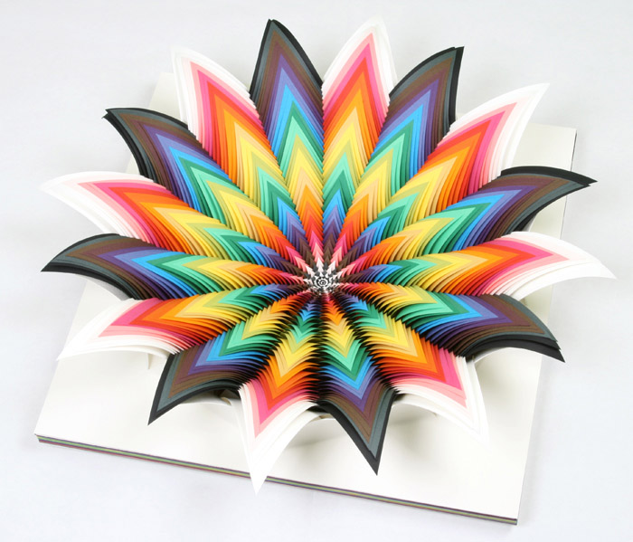

Jen Stark

Coriolis Effect

