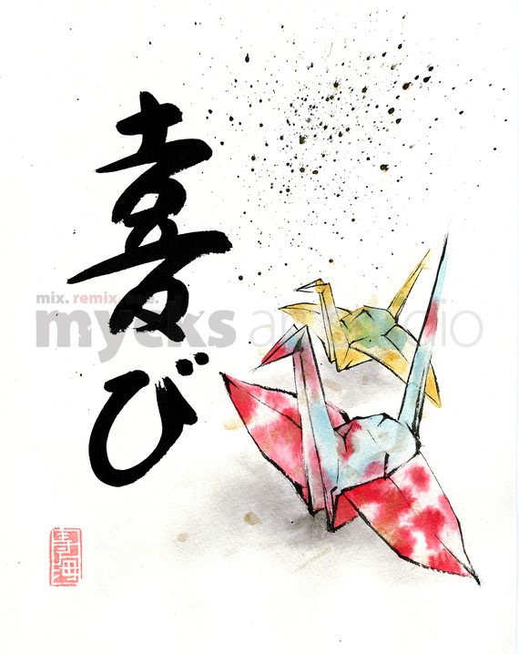
Watercolor Origami

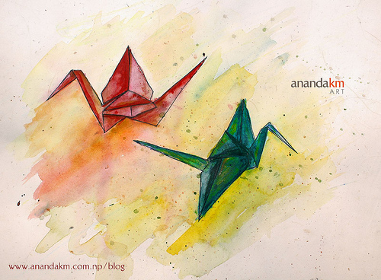

Using some of your own origami pieces combined with some from your supply bin, you will compose your own still life to create a watercolor painting.

- Draw at least 3 origami pieces, they can be all the same or different
  - Follow rules of composition, origami drawings should go off the page, change in size, and avoid being centered in the middle
  - Try to draw the angles of the origami piece as they appear. Pay attention to the direction of the line and crease in the folds
- Watercolor in each section of the origami piece
  - Use some of the techniques you learned from creating your watercolor book to help you create colors, patterns, and textures in your origami piece.
  - Include the designs or colors of each origami piece
- Background
  - You may fill in the background with other watercolor techniques as well.
  - Think about what would work best against the colors of your origami piece

Watercolor Lesson
Art II

Lesson Overview: This lesson is broken into three mini lessons, one where artists will compose a watercolor sample book, one on origami, then combining the two by turning the origami pieces into a watercolor still life.

Objectives
Knowledge: Learn new watercolor techniques and catalog them in a book for future reference
Skills: Following visual as well as oral directions on paper folding and creating origami
Dispositions: Combining two art skills and two very different art concepts into one final work

Procedures:

Day 1, 2: Students will construct a watercolor booklet of watercolor techniques. Each page will be labeled with each technique. Each page will be hole punched in the top corner and tied togeather.
- This is a 50 pt assignment

Day 3,4: Each student will choose an origami sheet and paper and practice creating a few types of origami. The teacher will rotate between tables and have students create a crane. This step by step instruction will help so that each student can leave with at least one piece.

Day 5,6: Students will use their origami pieces to compose a still life

1. Draw at least 3 origami pieces, they can be all the same or different
a. Follow rules of composition, origami drawings should go off the page, change in size, and avoid being centered in the middle
b. Try to draw the angles of the origami piece as they appear. Pay attention to the direction of the line and crease in the folds
2. Watercolor in each section of the origami piece
a. Use some of the techniques you learned from creating your watercolor book to help you create colors, patterns, and textures in your origami piece.
b. Include the designs or colors of each origami piece
3. Background
a. You may fill in the background with other watercolor techniques as well.
b. Think about what would work best against the colors of your origami piece

Materials: 4x4 watercolor paper, burshes, paints, 6x6 origami paper, pencils
Vocabulary: Watercolor gradation, wet on wet, resist, sponge, drip, origami

PA Standards
9.1.12.A: Know and use the elements and principles of each art form to create works in the arts and humanities.
9.1.12.D: Demonstrate specific styles in combination through the production or performance of a unique work of art (e.g., a dance composition that combines jazz dance and African dance).

