Watercolor Gradation
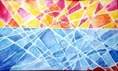
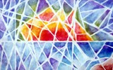

Procedures
- Each student will practice watercolor gradation by creating a sunset design and adding a watercolor gradation to add to the reflection
- Students will create a very fractured drawing to create an interesting design using a horizon line, a sun, and multiple dividing lines (at least 25)
- Each section will contain a watercolor gradation and broken design
To create a Watercolor Gradation:
- For the sun and sky: Use WARM colors: Reds, Yellows and Oranges
- For the Sea: Use cool colors like blues, and violets. You may turn your sea into land by using blue and green.
  - Concentrate a heavy amount of watercolor paint around edges
  - Using only water, face the paint using your brush like a windshield wiper and go back and forth
  - This should fade your paint from dark to light
  - Paint in every other space to avoid bleeding the paint
What I expect….
- Your participation and effort, try your best and be respectful
- A complicated design with enough broken images
- A watercolor gradation with each color either blending or changing from dark to light.

