Transformation drawing: Inorganic to organic drawing
Big Idea: Use value and imagination to change an object
Grade: Art III
Time: 5x 40 min class periods

http://community.webshots.com/photo/fullsize/1129727936052147247CPZoBt

Lesson Overview: Students will choose any object of their liking to draw in a still life. Their goal is to take the object and change it into something that is a complete opposite..ie. take an inorganic object and turn it into an organic object through 5 different scenes. This will challenge students creative skills as well as their critical thinking skills to get a transformation that makes sense.

Essential Questions:
What is value? What kinds of art tools can you use to render value?
How do artists use their imagination to change an object?
How can you come up with ways to transform an object into something completely different.
How do artists plan a work of art?
Practice makes perfect, which drawing is your favorite? Are you happy with the results?

Key Concepts:
Value makes an object look realistic.
Critical thinking and imagination are key elements in transformation drawing.
Certain colors perceive as certain values. Use them in a way to make your objects transform. They can be completely opposite or the same.

PA Standards for Arts and Humanities
9.4.12 A. Evaluate an individual’s philosophical statement on a work in the arts and its relationship to one’s own life based on knowledge and experience
9.1.12 B. Recognize, know, use and demonstrate a variety of appropriate arts elements and principles to produce, review and revise original works in the arts.

Interdisciplinary PA Standards: Math (matte cutting), Technology

Objectives:
Knowledge: Students will use previous knowledge of drawing and its vocabulary to set up a drawing for composition and value.
Skills: Students take their object and in a series of 5 drawing transform them into something completely different. (organic to inorganic or vice versa)
Disposition: Students will draw conclusions about how artists must use creativity to express their ideas and rate the difficulty of the project.

Procedures:

Introduction: The teacher will introduce the lesson through a power point presentation. Students will be instructed to choose and object of their liking and transform it through a 5 panel series into a completely different object. Students will brainstorm ideas through web bracketing to help facilitate the process. They will be allowed to draw from the real object or use a photograph as a reference. They will also have to transform from inorganic or organic drawing.

Development : After coming up with an idea, students will create 5 sketches showing the transformation of their object. They should practice warping, melting, inflating, and twisting the object in each scene to eventually create something completely different. The teacher will ask questions about how the object should change, will there be several scenes where the identity of the object is completely hidden? The teacher will then tell students to create 5 compositional drawings using just contour line before adding value with colored pencils. For example, students can take a spider, draw it several times transforming into a stiletto shoe with contour lines, then add the colored pencil value.

Conclusion: At the end of class, students will matte each one of their drawings and display them in a way that shows their transformations. Each student will present their drawings to the class in a critique. They should explain their choices for their drawings and why they chose the object. Students will conclude by completing a self assessment for a grade.

Vocabulary:
Value
Transformation
Web mapping
Critical thinking process
Group critique
Series work

Materials:
Chalk board
Student examples
Newsprint (large or medium size)
Hb, 4h and 6h pencils
Colored pencils
powerpoint

Instructional Tools:
Powerpoint
Transformation Artists:

Metamorphosis Drawings
The art of creating transformations

Lesson Overview: This lesson is aimed at challenging your drawing skills, imagination, and critical thinking. Your challenge is to take an inorganic object and transform it into an organic object by drawing the metamorphosis of the process in a series of 5 drawings. Your goal is to make this transformation appear possible. Imagine if you could wave a wand and make your object twist, pull, and turn into the something completely different.

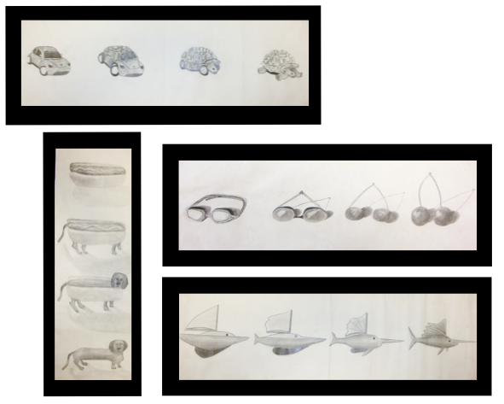
Essential Questions:
What is value? What kinds of art tools can you use to render value?
How do artists use their imagination to change an object?
How can you come up with ways to transform an object into something completely different?
How do artists plan a work of art?
Practice makes perfect, which drawing is your favorite? Are you happy with the results?

Day 1 Brainstorming: This is the most important step, you have to have a PLAN before you begin to draw. First, find your object. You can bring one from home or from the art room. Using this object, come up with some ideas to transform it. For example, a Pear to a Sailboat, or Sunglasses to a Lily flower. Come up with sketches for your metamorphosis drawing

Day 2-4 Creation: In a series of 5 separate drawings; start to illustrate your metamorphosis. Use contour line to sketch out all 5 stages, from inorganic to organic object. Use colored pencil to shade and add value to your sketches. The challenge will be to make the transformation relate with color as well. Maybe the colors blend, or slowly disappear in your new object.

Day 5 Critique: On this day be prepared to matte your artwork so that it can be easily views. Each piece should be matted either separately or together as one piece. After work is displayed, each person will share his or her decision making process to the class regarding their choices made and answering the Essential Questions. Finished work should be turned in with the self evaluation sheet for grading.
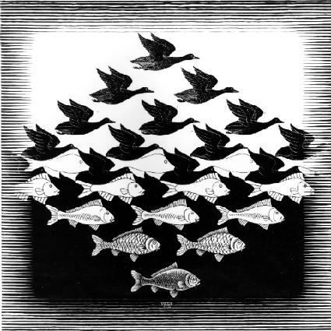
Artist: MC Escher
http://www.mcescher.com/
