Still Life Drawing
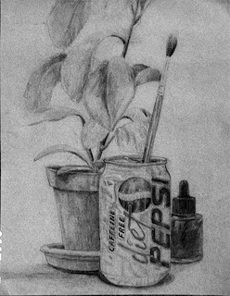
To practice drawing from observation, you will work on drawing from a still life. You will use a viewfinder to set up your composition, draw thumbnail sketches, work on an under drawing then shade with charcoal and white conte crayon.
- Practice drawing objects with thumbnail sketches
  - Create 4 thumbnail sketches of your still life
  - Nothing should be smack in the middle
  - Concentrate on object placement
  - Consider different views and angles, worms eye view or birds eye view
- Create a contour line drawing from one of your thumbnail studies
  - Draw so that your design fills the page
  - Draw in pencil
- Add Value with charcoal
  - Decide where the location of your shadows are and add value
- Use white conte crayon to add highlight
- Shade background or add horizon line
- Spray with fixative

