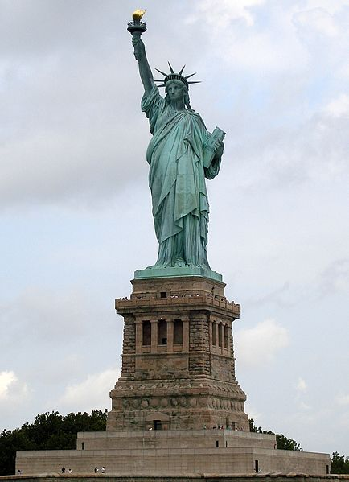
Statue of Liberty: Artist Frederic Bartholdi
Allegorical Sculpture:
Allegory is a figurative mode of representation conveying meaning other than the verbal. Allegory communicates its message by means of symbolic figures, actions or symbolic representation
The Statue of Liberty (Liberty Enlightening the World; is a colossal neoclassical sculpture on Liberty Island in New York Harbor, designed by Frédéric Bartholdi and dedicated on October 28, 1886. The statue, a gift to the United States from the people of France, is of a robed female figure representing Libertas, the Roman goddess of freedom, who bears a torch and a tabula ansata (a tablet evoking the law) upon which is inscribed the date of the American Declaration of Independence, July 4, 1776. A broken chain lies at her feet. The statue has become an icon of freedom and of the United States.
Design, style, and symbolism
A significant female icon in American culture was a representation of Liberty, derived from Libertas, the goddess of freedom widely worshipped in ancient Rome, especially among emancipated slaves. A Liberty figure adorned most American coins of the time, and representations of Liberty appeared in popular and civic art.
Artists of the 18th and 19th centuries striving to evoke republican ideals commonly used representations of Liberty. A figure of Liberty was also depicted on the Great Seal of France. However, Bartholdi avoided an image of revolutionary liberty such as that depicted in Eugène Delacroix's famed Liberty Leading the People (1830). In this painting, which commemorates France's Revolution of 1830, Liberty leads an armed mob over the bodies of the fallen. Bartholdi had no sympathy for revolution, and so his figure would be fully dressed in flowing robes. Instead of the impression of violence in the Delacroix work, Bartholdi wished to give the statue a peaceful appearance and chose a torch, representing progress, for the figure to bear
Bartholdi’s statue was designed in the early 1850s. It was originally to be crowned with a pileus, the cap given to emancipated slaves in ancient Rome. Secretary of War Jefferson Davis, a Southerner who would later serve as president of the Confederate States of America, was concerned that the pileus would be taken as an abolitionist symbol. He ordered that it be changed to a helmet. Instead, he used a diadem, or crown, to top its head. The seven rays form a halo or aureole.[20] They evoke the sun, the seven seas, and the seven continents, and represent another means, besides the torch, whereby Liberty enlightens the world.
“We will not forget that Liberty has here made her home;
nor shall her chosen altar be neglected."

— President Grover Cleveland accepting the Statue of Liberty
on behalf of the U.S., October 28th, 1886

An allegory stands for an idea. The Statue of Liberty stands in Upper New York Bay, a universal symbol of freedom. Originally conceived as an emblem of the friendship between the people of France and the U.S. and a sign of their mutual desire for liberty, over the years the Statue has become much more. It is the Mother of Exiles, greeting millions of immigrants and embodying hope and opportunity for those seeking a better life in America. It stirs the desire for freedom in people all over the world. It represents the United States itself.

How was the Statue of Liberty designed to be a allegory? How have circumstances enhanced its meaning?

How is your “Key to Creativity” an Allegory? What symbolism did you use? What does it represent? What does it say about you?

