Skate-Snow-Surf Board Deck Design

One of the fastest moving styles of contemporary art is taking place right underneath your feet! That is, with the deck design of sporting equipment with skateboards, snowboards, and surfboards.

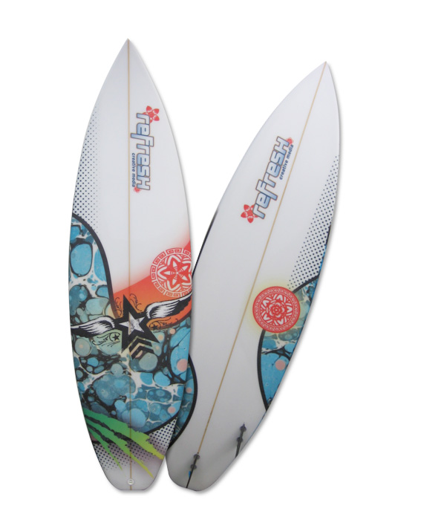
Modern artists take inspiration from music, sports, landscape, graffiti, tattoos, and world cultures. Your job is to design sketches for any of these three boards and come up with a plan to create one of your own. Your final copy will be done using a stencil on white paper, cut out your design, and mount onto a piece of cardboard to trim with glue and scissors.

Ideas for deck designs:

Elements and Principles of Art: line, shapes, patterns, textures, form, color
Modern Art
Tattoos
World Cultures
Nature
Cartoon Characters
Graffiti
Music Genres

RESTRICTIONS: Designs must be school appropriate! Nothing that would embarrass your grandma or Mr. Tucci

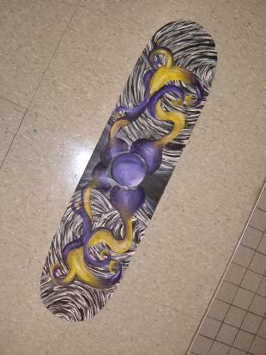
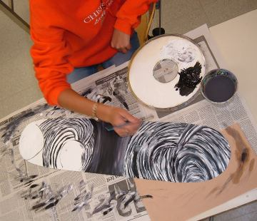

Websites for Deck Designs:

Check these websites for contact info:
- Baker Skateboards
www.bakerskateboards.com
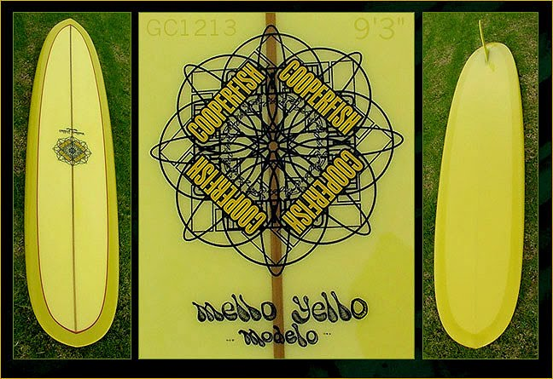
- Chocolate Skateboards
www.chocolateskateboards.com
- Black Box Skateboards
http://www.blackboxdist.com/
- Element Skateboards
www.elementskateboards.com
- Enjoi Skateboards
www.enjoico.com
- Toy Machine Skateboards
www.toymachine.com
- Seed Skateboards
www.seedskateboards.com
- Girl Skateboards
www.girlskateboards.com
- Habitat Skateboards
www.habitatskateboards.com
- Deluxe Skateboards
www.dlxsf.com
- Krooked Skateboards
http://www.dlxsf.com/spring10/kr/
- Check out the skateboard directory site for more companies:
www.skateboarddirectory.com

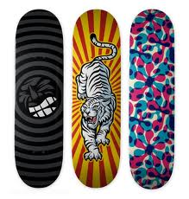

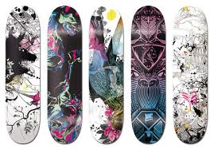

Skateboard Deck Design Template:

- Use this template to create a thumbnail sketch of your skateboard deck
- Draw in pencil
- Label on the side if you do not have enough room to create your design in this small space. I need to see that you have a plan
thumbnail sketch of your skateboard de

Snowboard Deck Design
- Use the template to create a thumbnail sketch of your snowboard design
- Draw in pencil
- Any designs that cannot fit, label in the side space

Surfboard Deck Design

1. Use the template to create a thumbnail sketch of your snowboard design
2. Draw in pencil
3. Any designs that cannot fit, label in the side space

