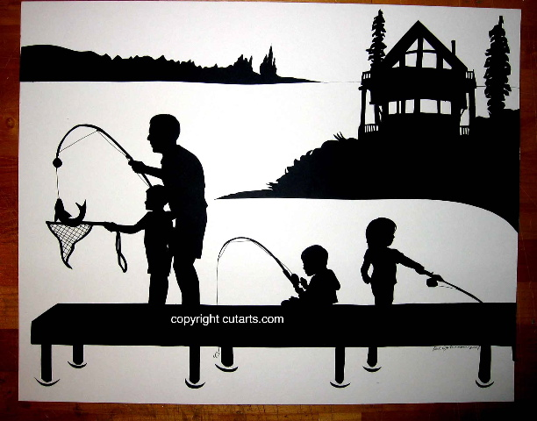
Big Idea: Silhouettes express human emotion in a graphic, high contrast, and shape focused way.
Grade Level: Art 1
Time Period: 4 class periods

Lesson Overview: Students will explore the elements and principals of art through shape, contrast and unity by creating silhouettes artworks. Each student will work as a pair to create a silhouette profile with a prop of some kind. Then, they can add more to their silhouette to add visual interest.

Content Standards:
PA Arts and Humanities:
- 9.1.12.B: Recognize, know, use and demonstrate a variety of appropriate arts elements and principles to produce, review and revise original works in the arts.
- 9.1.12.E: Delineate a unifying theme through the production of a work of art that reflects skills in media processes and techniques..
- 9.1.12.F: Analyze works of arts influenced by experiences or historical and cultural events through production, performance or exhibition..
Essential Questions:
- How are silhouettes created and what are the technologies used?
- How do silhouettes create an effect and simple form of communication?
- What can you add to your silhouette to make it more unbelieveable?
Key Concepts:
- Apple used silhouettes to make a catchy advertising campaign because of their simplification
- “Silhouettes” Dance team on AGT uses silhouettes as an artform for their dances
- Silhouettes are caused by a block in the light, the closer you are to the lightsource the smaller your shape will appear
Activity Strategy:
- Students will follow along with a power point, video segment, and create their own silhouette illustration
- Artists: Karl Sagan http://cutarts.com/
- Silhouettes Dance Group:
  - http://www.nbc.com/americas-got-talent/video/silhouettes-hollywood-performance/1341760/
  - http://www.youtube.com/watch?v=qpaCahFmruM
- Ipod Commertial: http://www.youtube.com/watch?v=ppY3DdnzQiA&feature=related

Accelerated Strategies: Student handouts, lightbulb projector, black paper, colored paper
- Vocabulary: contrast, shape, emphasis, silhouette, graphic arts

Procedures:
Day 1-2: Introduce silhouettes project by showing students examples of the videos
Practice negative space drawings, have students draw the space around an object to ‘guess’ what its silhouette would be
Use a projector to create a silhouette, trace the silhouette, and cut out the shape
Day 2-8: Add props to the artwork, for example, students may want to do their silhouette with a piece of sporting equipment or with an object
Student can add things that cannot be silhouetted…ie speech bubble, different types of lines, words, anything they can imagine
Students will then mount and display their works for viewing

Teaching Strategies
- Show images of silhouettes
- Create connections to personal cultural events
- Use media for display
  - Youtube features, Americas Got Talent
- Students will follow along with a demonstration and create their own silhouette
- Students will participate in class critique and draw their own conclusions
Extended Thinking Strategies
- What are the graphic arts? How is graphic art used to create advertisements?
Summarizing Strategies:
- Students will conduct a critique lesson
  - Was there a big idea or concept behind your silhouette?
  - What were some of the challenges in creating your work?
Materials/Resources:
- Drawing paper, power point, light bulb projector, large black paper, scissors, exacto knives, laptop computer with internet
- Assessment: PSSA exit question

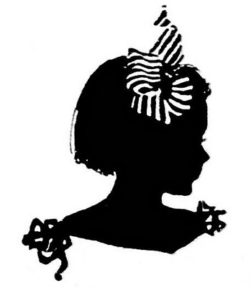
Silhouettes Lesson: Creating your own silhouette with a big idea

Students will create a silhouette based off of a big idea concept. More than just a profile image, student can use props and ‘fake’ (drawn separately) silhouettes to create their paper cut out
Warm up with some negative space drawing practice while you wait for your ideas to come to you

- Choose a Big Idea…..What is a BIG IDEA?

A big idea is a theme, or concept. It can apply to any art lesson. Here are some BIG IDEAS to choose from, there are many more. If you do not like any of these, you can create your own!
- Dreams, Night/Day, Nature, Environment, Identity, Culture, Celebration, Music, Power, Change, Conflict, Family, Community

- Brainstorm: What are some things that you could come up with for the big idea…say…Environment

  - What are some ideas of silhouettes that could work with the Big Idea ‘Environment’? Could you use silhouette images of animals, trees, or maybe the recycling logo with your silhouette? Could you use props for your silhouette? Maybe some gardening tools?

- One you have brainstormed your best idea, work with a partner to create your silhouette. Use the projector light to pose and have your partner trace the image onto black paper

- Cut out the silhouette with scissor or xacto knives. If you want to add additional silhouettes to your cutout you may. These could be things like lines and designs, shapes, or words

- Mount your finished project on large, white paper using rubber cement

- Write an ARTISTS STATEMENT about your work. The Artists Statement should include what worked well with your process and what didn’t. It should also explain your concept for your work, and how and why your big idea was incorporated into your artwork.

