Self Portrait
Art II

Objective: Students will learn about the proportions of the human face and practice facial features to create their own self portrait rendered in 4H pencil

Goal: To have some realism in your portrait, I DO NOT expect these portraits to be an absolute exact version of you! Mistakes are ok! What I am looking for is some recognizable features as well as proper proportions on the face. If your portrait does not look like you exactly, you will not receive a bad grade.

With effort and practice, you can be successful at drawing a realistic face. I will help you with each step along the way.

Step 1: Draw 2 of every facial feature on a piece of newsprint paper, with full value. Use the packets provided to you to help you. Reference them, and use the mirror to help you guide your drawing
Two eyes (10pts)
Two Noses (10pts)
Two Mouths, one opened and one closed (10pts)
Two Ears (10pts)

Step 2: On good drawing paper, draw your head
- Head should fill most of the page, and take the shape of an oval
- Draw the proper proportions for the human face using a ruler and very light lines
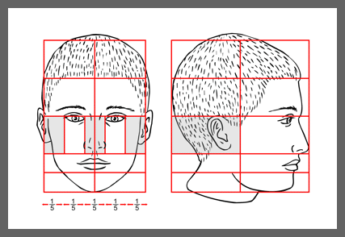
- Mark the areas for your eyes (eye width apart), nose (from corners of eyes), and mouth (from bottom of eyes) on your blank face

Step 3: Draw in your facial features
- Add your eyes, nose, and mouth with contour line.
- Add ears

Step 4: Draw hair
- Hair should start underneath the top part of your head, follow closely to what you see in the mirror
- DO NOT DRAW every strand of hair. Focus on sections of the hair, add value for the areas that are in highlight
  - Avoid taking your pencil and scribbling in spaghetti hair
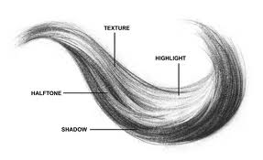

Step 5: Add value
- Using your mirror and your handouts as reference, shade around all of you facial features. Add value to hair as well
- If there is space, draw and add value to neck and shoulders in composition

