3D Letter Construction: Robert Indiana
Big Idea: Space and form play an important role in creating sculpture
Grade Level: Art 1
Time: 5 class periods

Big Idea: Silhouettes express human emotion in a graphic, high contrast, and shape focused way.
Grade Level: Art 1
Time Period: 4 class periods

Lesson Overview: Students will explore the artwork of Robert Indiana and his famous sculpture LOVE in Philadelphia. Each student will then create a letter sculpture as well. They will choose a specific typography to create the image

Content Standards:
PA Arts and Humanities:
•1-H (9 - 12) Students conceive and create works of visual art that demonstrate an understanding of how the communication of their ideas relates to the media, techniques, and processes they use

2-G (9 - 12) Students demonstrate the ability to form and defend judgments about the characteristics and structures to accomplish commercial, personal, communal, or other purposes of art

6-F (9 - 12) Students compare characteristics of visual arts within a particular historical period or style with ideas, issues, or themes in the humanities or sciences
Essential Questions:
• Robert Indiana never copywrote his work, so it was able to reproduced without anyone knowing it. Do you think this was fair? Do you think the companies should have to pay him royalty for his designs?
- What do you have to do to make the sides for your project? How can you figure out the space you need to cover
Key Concepts:
• Copy write helps to protect and artists work
- 3d sculpture still requires sketches to create a plan
- Sculpture should have components to be viewed from all sides
objective / assessment
objective: 1. Students will be able to identify artwork by Robert Indiana. 2. Students will be able to create a balanced 3-D form from a 2-D drawing. 3. Students will understand and be able to explain the meaning of Pop Art. 4. Students will be able to dicuss and explain how copyrights and laws pertain to artwork. 5. Given different types of typography, students will be able to identify moods of each.
assessment: none specified
rubric: none specified
materials & procedure
materials:
Pictures of Robert Indiana's sculptures
Article about Robert Indiana's infamous 'LOVE' controversy
Pencils
1 sheet of 9x12" white paper per student
Scissors
Cardboard
Box cutter or exacto knives
Hot glue gun and glue sticks
Flour
Water
Bowls or small tubs
Acrylic Paint
Brushes
procedure:
1. First, students read about Robert Indiana's work and viewed examples of his work. I introduced the idea of Pop Art and explained what made Indiana's work from the Pop Art movement. Then, students compared his work to what he was inspired by (road signs). Students created a Venn diagram to compare and contrast Indiana's work and road signs.
2. Students looked closely at the type of typography used in Indiana's work and compared it to the emotion of each word. We decided to use similar simple letters in our own project. For our project, students used one of their initials. However, another idea would be to have students choose a simple word like Indiana did or do the school name and have each student create one or two letters from that. Students drew out their letters using a sheet of 9x12" paper and cut it out.
3. Students traced their letter twice onto cardboard for the front and back of the letter and used box cutters and exacto knives to cut it out. They then cut the sides for the letter and glued it together using the hot glue gun.
4. Students mixed paper mache mix using flour and water and applied two coats of paper mache to their letters; one coat using newspaper strips and one using white paper towels. (The white paper towels create a blank slate on which to paint after the paper mache dries.)
5. As the paper mache dried, we examined another aspect of Robert Indiana's work - the use of the LOVE image. After reading an article that explained the lack of copyright and the use of the image, students discussed ownership aspects of artwork.
6. After the two layers of paper mache have dried, students painted and decorated their letters.
additional help
discussion questions:
1. What parts of Indiana's work reflects his inspiration?
2. How does Indiana's work fit the Pop art period? 3. How does Indiana's love sculpture differ from the actual meaning of love? 4. How would the sculpture look different if the O was not tilted? 5. How can different types of font change the look + feel of a word? 6. Was Indiana at fault for forgetting to copyright his work of art or were the companies using the artwork at fault? 7. What is the copyright policy for artwork at Artsonia?
resources:
http://en.wikipedia.org/wiki/Robert_Indiana
http://www.cbsnews.com/stories/2004/10/24/sunday/main651055.shtml
http://www.sma.shs.nebo.edu/swap/oapindia.html
followup activities:
After the sculptures are completed and put on the Artsonia website, students can use the website to do an in class critique. By using a project that hooks up to a monitor, students can view each others' artwork one at a time, critiquing each one. Often I set it up as a campaign, where students must campaign for someone else's work of art. After the campaign has finished, students vote and the winning work of art will be the one I enter in as the first work of art that is seen for that project.

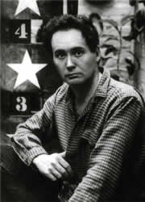
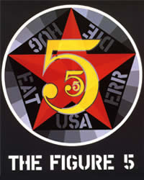
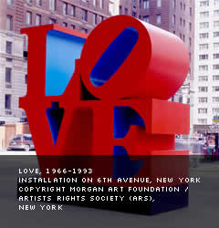

One of the pre-eminent figures of American art since the 1960s, Robert Indiana has been a pioneer of assemblage art, hard-edge abstraction and pop art. Over the past five decades, Indiana’s work has explored the power of abstraction and language, American identity and personal history. As a self-proclaimed “American painter of signs,” Indiana gained international renown in the early 1960s for employing the vernacular form of American road and shop signs, combining it with a sophisticated formal and conceptual approach that turned this familiar vocabulary into something entirely new. His distinctive rendering of LOVE, in paintings, sculptures and prints, has become an icon of 20th-century art.
Indiana’s artwork has been featured in numerous solo and group exhibitions around the world, and his work is included in the permanent collection of many important museums, such as the Museum of Modern Art and the Whitney Museum of American Art in New York, the Hirshhorn Museum and Sculpture Garden and the Smithsonian Museum of American Art in Washington, D.C., the San Francisco Museum of Modern Art, the Menil Collection in Houston, Texas, the Museum Ludwig in Cologne, Germany, Stedelijk van Abbemuseum in Eindhoven, Netherlands, the Museum Ludwig in Vienna, Austria, the Shanghai Art Museum in China, and the Israel Museum, Jerusalem. He has also been included in numerous international publications, including a number of monographs dedicated to his work.

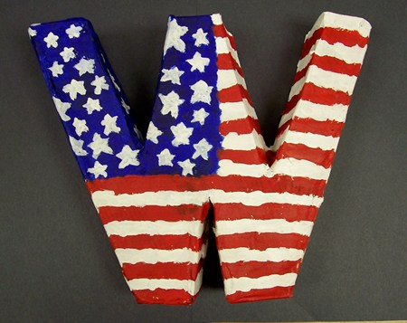

1. First, students read about Robert Indiana's work and viewed examples of his work. I introduced the idea of Pop Art and explained what made Indiana's work from the Pop Art movement.
2. Students looked closely at the type of typography used in Indiana's work and compared it to the emotion of each word. We decided to use similar simple letters in our own project. For our project, students used one of their initials. However, another idea would be to have students choose a simple word like Indiana did or do the school name and have each student create one or two letters from that. Students drew out their letters using a sheet of 9x12" paper and cut it out.
3. Students traced their letter twice onto cardboard for the front and back of the letter and used box cutters and exacto knives to cut it out. They then cut the sides for the letter and tape together with the sides.
4. Students mixed paper mache mix using flour and water and applied two coats of paper mache to their letters.
5. As the paper mache dried, we examined another aspect of Robert Indiana's work - the use of the LOVE image. After reading an article that explained the lack of copyright and the use of the image, students discussed ownership aspects of artwork.
6. After the two layers of paper mache have dried, students paint and collage their letters.

discussion questions:
1. What parts of Indiana's work reflects his inspiration?
2. How does Indiana's love sculpture differ from the actual meaning of love?
3. How would the sculpture look different if the O was not tilted?
4. How can different types of font change the look + feel of a word?
5. Was Indiana at fault for forgetting to copyright his work of art or were the companies using the artwork at fault?

What I am looking for:

Exacto knife safety; each person handled the exacto knife properly.
6 different sketches of letter design
2 cardboard cut letters cut from the exacto blade and scissors
Sides to the 2 cardboard cutouts
Paper mache and collage elements added.

