Right Brain Vs. Left Brain
The right and the left brain work together to support learning
Grade: ART II
Time: 4x 40 min class periods

Lesson Overview: Students will explore the findings between what makes the right brain different from the left brain and how they assist in learning. Students will take a survey to learn about whether or not they are more right brained or left brained and use those findings to create a metaphorical illustration about their right or left brains

Essential Questions:
How are the right and the left brain different?
How do we use the right brain to draw?
What makes an effective illustration?
What is the purpose of brainstorming?

Key Concepts:
The right brain helps us to draw from observation and to see the big picture.
Illustrations are artistic and creative pictures used for explaining ideas.

PA Standards for Arts and Humanities
9.1.8 E. Delineate a unifying theme through the production of a work of art that reflects skills in media processes and techniques.
9.1.8C C. Identify and use comprehensive vocabulary within each of the arts forms.

Interdisciplinary PA Standards: Technology

Objectives:
Knowledge: Students will use various art skills with 2d media to create a meaningful illustration
Skills: Students will use the information found in their survey to create ideas for their illustration.
Disposition: Students will draw conclusions about the information found in their survey and use that to form ideas about the way they learn

Procedures:

Introduction: The teacher will introduce the lesson through a power point presentation. Students will learn about how the right brain and the left brain serve different functions for learning. They will then participate in a survey to view results on which side is stronger. By summarizing their findings, they will then use these ideas in their artwork

Development : Using the research found from the survey, students will create a metaphorical illustration inspired by right vs left brain concepts. Using any 2d media, the illustration should be an artistic interpretation of their findings.

Conclusion: Each student will present their artwork to the class and explain how they used their findings from research to come up with the ideas they had for their artwork. Each work should be matted and displayed along with an artist statement about their project.

Vocabulary:
Brain mapping, cerebral cortex, brain stem, cerebellum, right vs. left brain, illustration, metaphore

Materials:
Newsprint, drawing paper, various tools, various pencils, chalk pastel, watercolor, rulers, images, magazines, collage media, crayons, markers, pens, ink

Instructional Tools:
Powerpoint
Right VS. Left Brain Quiz and questions:

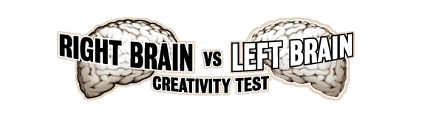

Which Brain do you think you will be, Right, Left, Both? Why?

Based off of your results from taking this quiz: http://www.wherecreativitygoestoschool.com/vancouver/left_right/rb_test.htm

Answer the following questions:

- What were your percentages from your survey? Summarize your results? What did you find?

- What was your highest area in LEFT BRAIN learning? What does this conclude about the way you learn?

- What was your lowest area in LEFT BRAIN learning? What does this conclude about the way you learn?

- What was your highest RIGHT BRAIN learning? What does this conclude about the way you learn?

- What was your lowest RIGHT BRAIN learning? What does this conclude about the way you learn?

- Explain why your RIGHT BRAIN helps you in art? What facts did you find in this survey that would support that?

- Were you surprised by your results? Where they what you expected? Do you think this is the only valid way to tell if you are more right or left brain?

Right and Left Brain: An Illustration Project

Goal: Based off of your findings from your survey and your knowledge of the right and left brain, you will create and INTERESTING, CREATIVE, ILLISTRATION (not a science handout) on the right and left brain.

You may use any 2D media (colored pencils, charcoal, ink, markers, crayons, collage, watercolor, chalk pastels, oil pastels)

Be imaginative! Use good balance, MUST include a ‘brain’ image of some kind.

Remember: This is a project to see how you use your creativity, show me what you can do.
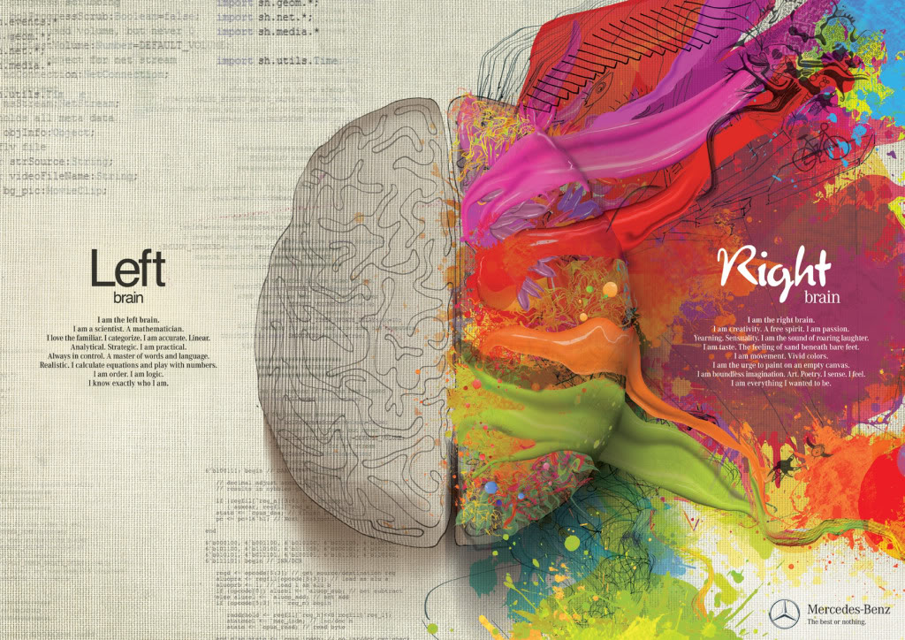

Illustration: an image or picture that a comparison or an example intended for explanation or corroboration. It is to illuminate and interest the viewer. It is a work of Art, not a face sheet.

