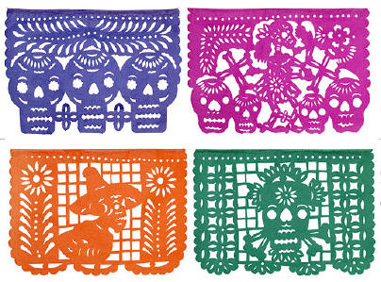
Papel Picado

The traditional art of Papel Picado or Mexican tissue paper cutout banners (literally perforated paper) is a skill that an artist must learn over many years to perfect. Many papel picado are made especially for the Mexican festivals of the Days of the Dead (dia de los Muertos) and include skeletal figures engaged in the everyday activities of the living. Other popular designs like Christmas nativity scenes, floral and garden motifs as well as love, birthdays, anniversary and weddings. Individual papel picado banners are strung together to create festive, colorful decorations for celebrations.
- Brainstorm some ideas for your cut paper papel picado. Remember that you will be working on the reverse side of your project, so that any of the pencil lines will not show
- Sketch your design. All areas you want to create a pop-up add a dotted line so that you do not remove the piece completely.
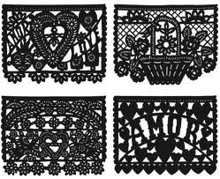
- Use and xacto knife to cut your paper. You must follow the sign out procedures to receive your knife. Always make sure you have a board or a piece of cardboard underneath your design before you start.
- Mount your projects on a piece of white drawing paper.

