Lesson Plan Starter: Masks
by Dena Lemelin
from Richmond Christian School (Chesterfield, VA)
submitted Nov 12, 2009

for grade level » High (9-12)
duration » 5 sessions (about 90 minutes per session)
media type » Mixed Media
sample student artwork
Click here to view all 22 artworks.

curriculum integration
subject integration: Multicultural
content standards:
1-H (9 - 12) Students conceive and create works of visual art that demonstrate an understanding of how the communication of their ideas relates to the media, techniques, and processes they use
2-G (9 - 12) Students demonstrate the ability to form and defend judgments about the characteristics and structures to accomplish commercial, personal, communal, or other purposes of art
3-E (9 - 12) Students reflect on how artworks differ visually, spatially, temporally, and functionally, and describe how these are related to history and culture
4-H (9 - 12) Students describe the function and explore the meaning of specific art objects within varied cultures, times, and places
5-H (9 - 12) Students describe meanings of artworks by analyzing how specific works are created and how they relate to historical and cultural contexts
6-E (9 - 12) Students compare the materials, technologies, media, and processes of the visual arts with those of other arts disciplines as they are used in creation and types of analysis
objective / assessment
objective: 1. Learn a very basic method of creating masks and to appreciate cultures/customs as well as to create their own "culture" 2. Learn how to manipulate various mediums: wire, paper mache, paint, and clay 3. Integrate design elements as well as sculptural elements assessment: none specified rubric: none specified
materials & procedure
materials:
1. Mask mold (simple plastic mask from local craft store)
2. Paper Mache
3. Sculpt-It Clay
4. Wire mesh
5. Paint, fabric, newspaper clippings, feathers, etc. procedure:
1. Student will sketch out at least 5 mask ideas in sketchbook. Research masks within culture and the significance. Show examples of modern artists and masks.
2. Student will begin to shape up wire and/or clay ontop of the mask mold depending on design. IE: Tendrils of mesh to create fire, or horns. Clay to shape up brows, cheeks, and other facial characterisits.
3. Student will immediately cover clay (if used) with paper mache so that the clay will NOT dry out over night.
4. Student will apply at the very MINIMUM 5 layers of paper mache. Four layers in front, one layer in back. Make sure eye hole and edges have been over lapped so that the edging won't be rough.
5. Once the paper mache is dry, he/she can begin to paint and add on other material to the mask.*

* One student of mine used cut out pieces of fabric to cover her mask.
additional help
discussion questions: none specified resources: none specified followup activities: none specified

Mask Making Handout
Objective: to create a mask based upon inspiration from carnival, dia de los muertos, and other cultural designs
Essential questions: Why to cultures make masks? How do masks play a role in American cultural identity?

- Create a doodle sketch for your mask
- Cover your mask mold in Vaseline, then apply wet plaster over your mask. Use at least 2 layers. IF you want to build up extra features overtop, use newspaper and masking tape followed by a layer of plaster.
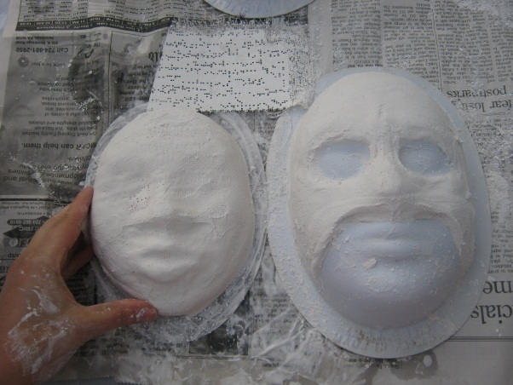
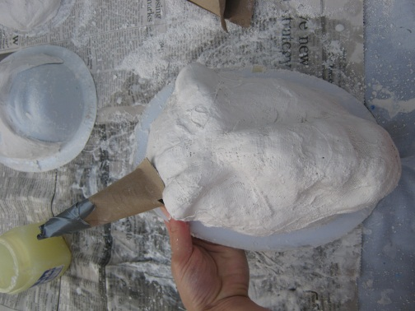
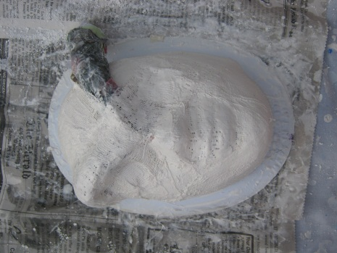
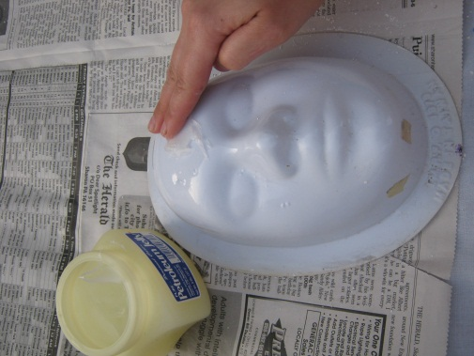

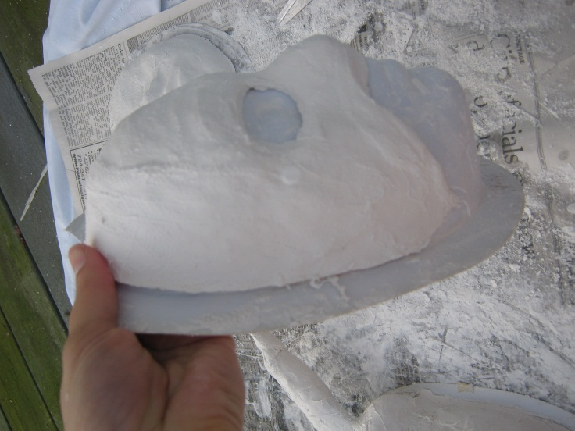
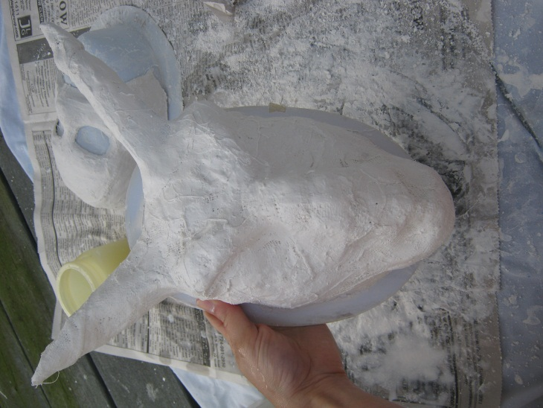

- Allow mask to dry overnight, sand down edges and cut loose ends
- Paint mask with acrylic paint and gloss
- Glue features such as glitter, feathers, and beads to your mask
