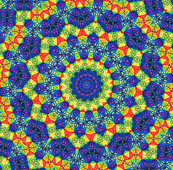
Kaleidoscope ‘stained glass’ Collage

Have you ever looked through a Kaleidoscope? An old fashion toy, looking through a kaleidoscope showed the viewer an array of colorful shapes while turning the device. You will create a kaleidoscope design using radial symmetry and collage techniques.

Vocabulary: Kaleidoscope, Radial Symmetry, Collage

- Divide your 12x12 piece of paper in half both ways and in half both ways from the corners. You should have 12 triangle sections.
- In one triangle section of your composition, create a basic design. The design should be simple, no shading, so that it is easy to collage. Think basic shapes.
- Trace that design onto a section of tracing paper and cut out the triangle section. Share the scrap paper with the rest of the students at your table.
- Flip the tracing paper pencil side down to the next space and press over the lines with your pencil. This should transfer the design
- Continue to flip and trace your design until you have created Radial Symmetry, where the design is the same in each space around.

Adding Tissue paper:
- Trace your design onto a piece of acetate paper. You will collage the tissue paper on top of this design
- Using a glue bath and small, torn strips of tissue paper, collage in each space around your composition. Colors should repeat in each section.
- Keep your piece in your bin or on the drying rack if it is very wet. Do not worry if the edges curl, we will press then down later with heavy books.
- Your design in complete then tissue paper correctly covers the entire space.

What I am looking for….
- A correctly drawn design with radial symmetry
- Good craftsmanship with the tissue paper, all areas are covered
- Proper procedures with following steps and cleaning up supplies
- Effort, focusing on your project during class time.

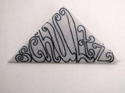
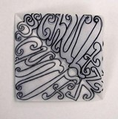
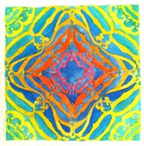
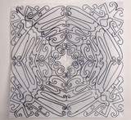

Art II
Kaleidoscope Collage

Lesson Overview: Students will create a kaleidoscope design from tissue paper collage

Objectives
Knowledge: How to use tools to create radial symmetry in a design and math concepts
Skills: Paint brush techniques and collage use with glue bath
Dispositions: Critical thinking in terms of choosing a successful, complicated yet simple design

Procedure:
1. Divide your 12x12 piece of paper in half both ways and in half both ways from the corners. You should have 12 triangle sections.
2. In one triangle section of your composition, create a basic design. The design should be simple, no shading, so that it is easy to collage. Think basic shapes.
3. Trace that design onto a section of tracing paper and cut out the triangle section. Share the scrap paper with the rest of the students at your table.
4. Flip the tracing paper pencil side down to the next space and press over the lines with your pencil. This should transfer the design
5. Continue to flip and trace your design until you have created Radial Symmetry, where the design is the same in each space around.

Adding Tissue paper:
1. Watercolor a light wash in the areas you want to collage. This is just to help hide any exposed white space created from the tissue papers in case you cannot cover all the paper.
2. Using a glue bath and small, torn strips of tissue paper, collage in each space around your composition. Colors should repeat in each section.
3. Keep your piece in your bin or on the drying rack if it is very wet. Do not worry if the edges curl, we will press then down later with heavy books.
4. Your design in complete then tissue paper correctly covers the entire space.

Materials: 12x12 Drawing paper, Tracing paper, rulers, pencil, glue and water containers, old burshes, watercolor paints

Vocabulary: Kaleidoscope, Radial symmetry, collage

PA Standards:
9.2.12.A: Explain the historical, cultural and social context of an individual work in the arts.
9.3.12.A: Explain and apply the critical examination processes of works in the arts and humanities.
9.1.12.J: Analyze and evaluate the use of traditional and contemporary technologies for producing, performing and exhibiting works in the arts or the works of others

