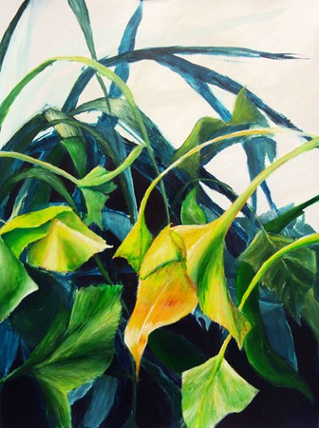
Jungle Chalk Pastel
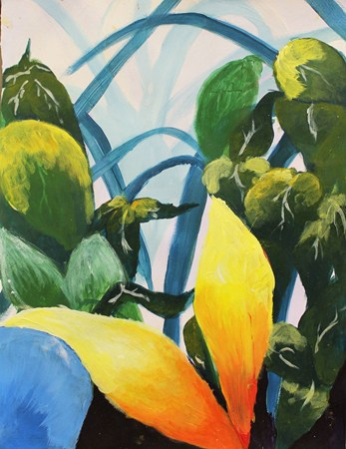
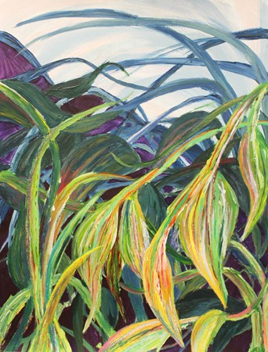

Procedures:
- Draw your still life from bottom to top, you can make some changes along the way. I am looking for
  - Big leaves that go off the page on the bottom
  - Small leaves at the top
  - The proper shape and vein detail in your leaves
- To shade with chalk pastel, start with adding any background value
- Work from the back of the artwork to the front
- In each leaf
  - Add a mixt of value to the greens
    - Try adding browns, reds, yellows and oranges to the leaves. It is ok if they change color slightly
    - Blend colors to smooth texture
    - Leave chalk pastel unblended to create veins and lines in the leaf.
- When drawing is complete, spray all artworks with fixative to keep them from smudging

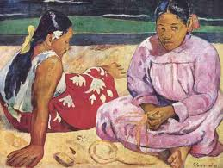
Tahitian Women by Paul Gauguin

Gauguin was a post-impressionist painter who’s influence was in his works of jungle paintings and natives from the islands of Tahiti and Singapore. As you draw, try to take some inspiration from the way that Gauguin added different colors to create the value of greens in his artworks.

