Composition with Hands: Full charcoal rendering
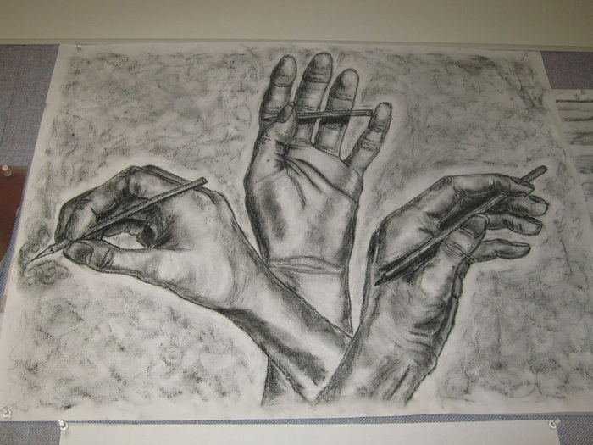
Big Idea: Hands are often the subject matter in fine art
Grade: Art IV
Time: 5x 40 min class periods

Lesson Overview: Students will learn about building a portfolio by meeting the specific criteria for an Advanced Placement program. Each individual will be required to create some kind of composition using their hands as subject matter. Students will be tasked with creating an image that is interesting and becomes more than just a study of human anatomy.

Essential Questions:
How does composition play a role in creating an interesting image?
What is chiaroscuro?
How do hands show self expression? Emotion?
Who has used hands as a subject matter in the past?

Key Concepts:
Value makes an object look realistic.
Composition is the key for combining simple elements such as hands to create an interesting drawing.
They way things are lit can add emotional content to a drawing.

PA Standards for Arts and Humanities:
9.1.12 C. E. Delineate a unifying theme through the production of a work of art that reflects skills in media processes and techniques.
9.4.12 G G. Analyze works in the arts by referencing the judgments advanced by arts critics as well as one’s own
analysis and critique.

Interdisciplinary PA Standards: History, Anatomy, Science

Objectives:
Knowledge: students will learn about artists that have used hands a subject matter in their works and complete several studies of their own hands.
Skills: Students will use their own hands and review anatomy of hands, how you can create sketches and studies for a work of art, and create one final composition of the design.
Disposition: Students critique their work at separate times during the class to examine their drawing process along the way and to share ideas before the work is finalized.

Procedures:

Introduction: The teacher will introduce the lesson through a power point presentation. Students will examine different artist’s works with hands as a subject matter as well as the art Elements and Principals of design that make them an effective work of art. Students will then be instructed to create several small compositional sketches of their hands as part of a plan for a final work of art.

Development: After sketches and preliminary drawings are complete, students will share their ideas as a group briefly to discuss a plan of action to being a large composition. Once plans are finalized, students can begin to draw light contour line drawings on the paper. Students will then add charcoal, white conte crayon, and pencil to render their drawings. Background is optional, but should be considered if it will help the composition.

Conclusion: At the end of class, students will matte each one of their drawings and display them in a way that shows their transformations. Each student will present their drawings to the class in a critique. They should explain their choices for their drawings and why they chose the object. Students will conclude by completing a self assessment for a grade.

Vocabulary:
Composition
Chiaroscuro
Value
Preliminary sketches

Materials:
Chalk board
Student examples
Newsprint (large or medium size)
Charcoal paper
Conte crayon
Powerpoint
Student handouts

Instructional Tools:
Drawing Dynamic Hands: http://www.amazon.com/gp/product/0823013685?ie=UTF8&tag=incredibleart-20&linkCode=as2&camp=1789&creative=9325&creativeASIN=0823013685
Drawing Real Hands:
http://www.amazon.com/gp/product/0891348174?ie=UTF8&tag=incredibleart-20&linkCode=as2&camp=1789&creative=9325&creativeASIN=0891348174

Resources on hands artists:
http://www.princetonol.com/groups/iad/lessons/middle/hands.htm

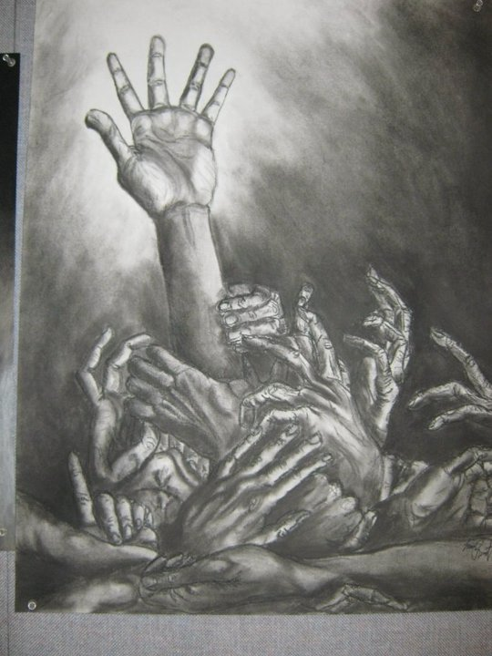

A Bouquet of Hands: A starter lesson in Anatomy and Composition
Advanced Placement Studio Art

Lesson Overview: A key essential in any portfolio or artists skill level is the drawing of hands. As complicated a form as the human face, hands can be used to express emotion, have a historical significance, and communicate messages to the viewer. In this lesson you will be tasked with the challenge of drawing at least 3 hands in an arrangement to create a dynamic, aesthetic composition.

Essential Questions:
Where are hands used as subject matter in art?
How are hands used to communicate?
How are hands in art used to show emotion?
How can you arrange hands in a way to create and interesting and compelling composition?

Procedure:

Day 1-3, Practice Sessions: Students will learn about the historical reference of hands in artwork throughout art history from past to contemporary art. Each student will then complete a hand study for guided practice. This will include gesture drawing, contour drawing, as well as create sketches for a large, final composition. Sketches will be reviews in a group critique to discuss ideas for layout and begin to transfer their drawing to large, charcoal paper.

Day 3-6, Rendering in Charcoal: Students will complete a light pencil drawing on the paper of their hand arraignment and use charcoal and white conte crayon to add value and light. The teacher will explain how to use the charcoal to add value so that the hands can look realistic, or have interesting lighting. Students should experiment first on practice paper before moving to their good copy (especially if you are unfamiliar with charcoal).
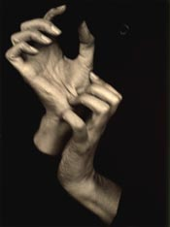
Day 5-6, Finalize work and Critique: Completed artwork should be sprayed with a matte fixative and mounted on paper for safekeeping. Students will then participate in a class critique to analyze and discuss their decision making throughout the process. Each artist can make any last minute changes to their work before completing the self evaluation sheet to turn in for a grade.

About the Artist: Alfred Stieglitz

http://www.metmuseum.org/toah/hd/stgp/hd_stgp.htm

Stieglitz photographed the following hands of Georgia O’Keeffe, another famous artist. How does the composition, value, and movement of the photograph make you feel? What message is being conveyed?

Learn How to Draw Hands
Learning to draw hands is easier than it seems, as though they are complex forms, they become less daunting by simplifying the shapes. The formulaic approach to drawing hands using circles and ovals is helpful to start with, but the shapes needed will change according to the position of the hand, so it is much better to train your eye to see what is required. It can help to see each part of the finger as a short cylinder, depicted with an oval overlapping the next to form the joint, but from there the subtle variations of shape must be built up.
1. Rough in the overall form.
Imagine the hand is encased in a tight mitten, and sketch the basic shape formed by the hand and fingers. Mark the imaginary lines through the joints.

2. Form the fingers.
Observing carefully the shape of the space between them, draw and check the relative size and placement of the fingers and thumb.
3. Refine the drawing.
Indicate the main visible creases, especially where the thumb folds into the hand. Refine contour lines defining the palm and thumb.
4. Describe the form with tone.
Here some rough shading is added to bring out the form of hand. Once you have the basic form down, try more subtle shading, and observe the fine lines and visible veins.
In this example some fingers are partially hidden. Draw the closest finger first and allow the others to sit in behind it, drawing only the portion you can see, or lightly indicating the hidden lines to help judge proportion.

