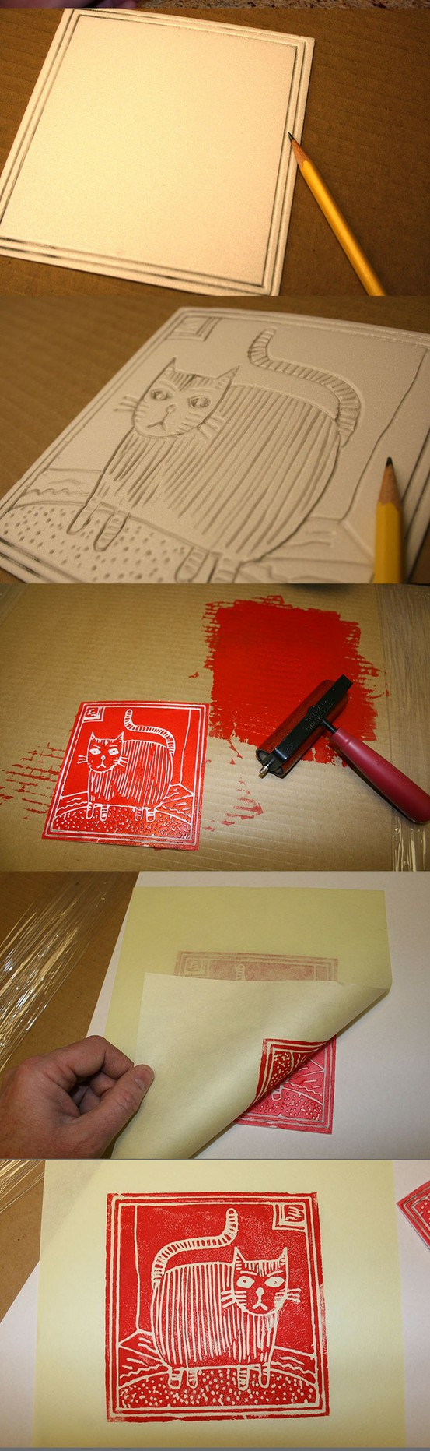
Foam Embossing Printing
Printmaking is one of my absolute favorite forms of art…why? Because you can make many additions of one drawing! In this lesson I will teach you how to create an embossing, how to create a print, and label editions as your work.

- Choose a subject to create for a print and create a sketch
  - MAKE your subject something detailed and interesting. It can be an imaginary landscape, animal, nature, machine, design, pattern, incorporate words. You may choose here BUT
  - Must have multiple, detailed lines. It cannot just be a contour line. Think about adding cross hatching or a design.
  - You must create a sketch of your print. Think about using lots of lines. More lines make a more interesting print
  - Make your sketch on 8x10 paper, the same size as your foam.
WARNING:
If you do WORDS of any kind, they must be done backwards. Any print that you create prints in REVERSE. In order to read words, you must draw them backwards.
- When you have an approved sketch, with lots of interest, you can emboss your foam
  - To emboss means to press
  - Tape your newsprint sketch over your foam and trace over the lines
  - Remove your sketch and re-do all of the lines you embossed
  - Add detail
- Assemble your printing station
  - Have a variety of papers cut to size
  - Cover table with newspaper
  - BRAYER, ink, printing pallet, and pencil
  - Apply a decent coat of ink to your foam print with the brayer and press your paper on top carefully. Apply pressure with a spoon, or BARREN.
- Pull your print away from the foam carefully. Each print should be labeled with your name and edition. Editions are the number of prints. They are done in the form of a fraction.
  - Ex: Ms. Herman, 1/10 (for print one out of ten)
- Let prints dry on the rack, turn in two successful prints for a grade. Mount them on construction paper.

