Elements and Principles Collage
Art I lesson
Kelly Herman
Greenville Art

Lesson Overview: Students will continue to explore the Elements and Principles of Art by creating visual examples of the same image using one principle or element each. Students will experiment with different materials and learn the transfer method.

Essential Questions:
- How do the Elements and Principles of Art apply to creating a piece?
- What are the differences and similarities between the Elements and Principles of Art

Key Concepts
- Transfer method requires graphing the back of a drawing to repeat the image
- Different materials used together are called Mixed Media

Standards:
9.1.12.A:
Know and use the elements and principles of each art form to create works in the arts and humanities.
Elements
- Dance: • energy/force • space • time
- Music: • duration • intensity • pitch • timbre
- Theatre: • scenario • script/text • set design
- Visual Arts: • color • form/shape • line • space • texture • value
Principles
- Dance: • choreography • form • genre • improvisation • style • technique
- Music: • composition • form • genre • harmony • rhythm • texture
- Theatre: • balance • collaboration • discipline • emphasis • focus • intention • movement • rhythm • style • voice
- Visual Arts: • balance • contrast • emphasis/focal point • movement/rhythm • proportion/scale • repetition • unity/harmony
9.1.12.B:
Recognize, know, use and demonstrate a variety of appropriate arts elements and principles to produce, review and revise original works in the arts.
- Dance: • move • perform • read and notate dance • create and choreograph • improvise
- Music: • sing • play an instrument • read and notate music • compose and arrange •improvise
- Theatre: • stage productions • read and write scripts • improvise • interpret a role • design sets • direct
- Visual Arts: • paint • draw • craft • sculpt • print • design for environment, communication, multi-media
9.1.12.C: Integrate and apply advanced vocabulary to the arts forms

Materials: 9x Square drawing paper, one newsprint of the same size, various art materials (including fabric elements) glue, scissors

Procedures:
Day 1: Students will have already reviewed the EPA from the previous lesson and have some familiarity with the definitions of each. They will then choose 9 to be the inspiration for each piece of their collage.
Students will create a sketch on newsprint paper, it can be an object, symbol, scene, or number. They will then transfer this drawing to each of the 9 sheets of drawing paper. Each drawing paper will then get a label on the back, of the students name and the element or principle used in each.

Day 2-4: Design day, from each of the 9 works created, students will use one element or principle to illustrate their work. For example, if the Principle is Proportion, the student may draw a large vs. small example. If the Element is Value, students may choose to draw their square with shading from pencil.

Day 5: Each of the 9 squares will be arranged in 3 rows and 3 columns. They will then be matted on a piece of construction paper with an artists statement describing each one.

Critique: Students will display their work and critique each others projects. They will have to guess which elements and principles were used where.

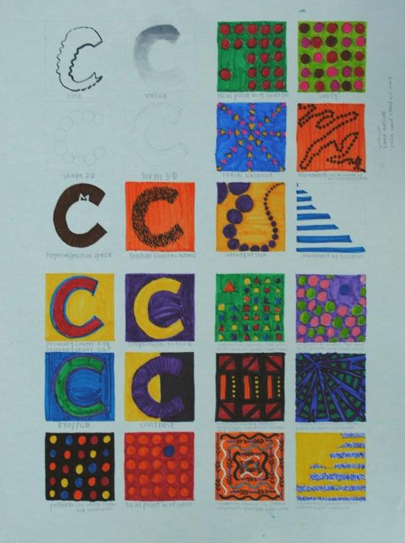

Elements and Principles Square:

Now it is time to draw! Using what you know of the Elements and Principles of Art, you will create a collage design that uses each as a ‘mini’ work of art.

  - On a 4x4 sheet of newsprint, draw any picture, symbol, logo, item, art supply, ect…
    - On the back of your drawing, cover the surface with graphite
    - Lay your newsprint piece of paper graphite side down, drawing side up, onto a piece of 4x4 drawing paper
    - Vowala! Your image will have transferred, complete this step 9 times
  - On each of your 9 drawing papers, label the back with a different Element or Principle of Art
    - For example, you may label one square VALUE, and shade the piece
    - Or, you may label one square BALANCE, and show how the drawn object has symmetry
      - Each square should be illustrated with a different Element or principle of art
  - Final Step: Glue all of your 9 Squares to a black piece of paper for matting
    - Complete the Elements and Principle of art critique sheet
    - Turn in the critique sheet to the teacher

Complete critique sheet on the back of this paper……for a grade

Elements and Principles of Art Square: Critique sheet

- What Elements or Principles did you use to illustrate your picture? Go from right to left…

1.

2.

3.

4.

5.

6.

7.

8.

9.

Which Element or Principle was the easiest to illustrate? Why?

Which Element or Principle was the hardest to illustrate? Why?

- With your table, play a guessing game to see if you can guess what Element or Principle of Art was used where. How many did you get correct?

Are there any Elements or Principles of Art that are very similar? Could you use two in one illustration?

Did you notice any other cool ideas from other classmates in their project? If you could, would you do anything different in your artwork?

