Cut Paper Kirigami
First Stage:
1. Using the 12" T-square ruler, divide the 12" by 18"(30.5 x 46 cm) piece of drawing paper into 2" by 2" (5 x 5 cm) squares.
2. With a pencil and the aid of the ruler and architectural template, draw each of the designs pictured below.
The dashed lines are where the paper should be folded; the solid lines are where the paper should be cut.
The designs should be centered within the squares.
3. Using an X-acto knife, carefully cut the designs as shown in the diagrams.
4. Fold over the dotted lines carefully, forming the required creases.
5. Fold each tab to produce the relief effect.
6. Now, experiment with your own creative ideas using the preliminary designs as a springboard for your own ideas.
7. After deciding on at least two ideas, continue on to the second stage.
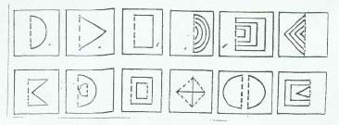
Second Stage:
- Using a 12x18 sheet of paper, measure a 1 inch boarder around all the sides.
- From the top, measure 3 inches and draw a line.
- From your three inch line, measure ¼ of an inch and draw a line.
Continue this to the bottom and along the top.
- Choose your pattern from your test sheet that you liked best. Every other square cut out your design
- In the opposite square, keep your design attached at the sides
- When finished, glue the project pencil side down to a piece of colored construction paper.
- Put your name on the back of your artwork and turn in to my desk.

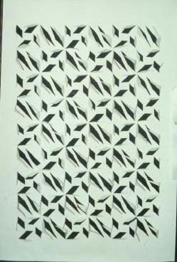

X-Acto Knife Safety
Follow these rules for proper knife safety.
- Sign out your x-acto knife with your teacher. Make sure you
record your knife number and the time.
- Keep the knife with your at all times. If you leave to go to the bathroom, sign your knife back in to the teacher. DO NOT leave your knife lay at your table.
- Put cardboard or a buffer underneath your cutting area.
- Make slow, shallow cuts
- Keep your knife blade away from other students and yourself
- Hold knife by handle.
- Return knife and sign in at the end of class.
Failure to follow these rules will result in removal from knife use and detention. Please take your time and be safe.

