Cubism drawing: Pablo Picasso Drawing
Big Idea: Use value and imagination to change an object
Grade: Art II
Time: 5x 40 min class periods

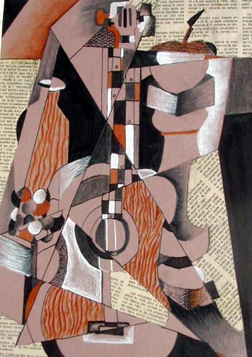
Lesson Overview: Students will review the history of cubism and collage and how Pablo Picasso and George Braque brought these concepts to the forefront of the art world. Students will also review how the history of the time period and the events happening then helped to influence this art movement. To gain inspiration, students will create cubism and collage inspired artwork.

Essential Questions:
How did cubism and collage change the art world?
Why were these changes shocking, what was going on during the time period that influenced that change?
How can you use the cubist influence to create your artwork?

Key Concepts:
Cubism is working with simplification and Collage works with additional paper media to create a tree 3D work.
Quick changes in political scenes helped to foster the influence of artwork at the time.

PA Standards for Arts and Humanities
9.2.12.D: Analyze a work of art from its historical and cultural perspective.
9.3.12.D: Analyze and interpret works in the arts and humanities from different societies using culturally specific vocabulary of critical response.
Interdisciplinary PA Standards: History
8.1.9.B: Compare the interpretation of historical events and sources, considering the use of fact versus opinion, multiple perspectives, and cause and effect relationships.

Objectives:
Knowledge: Students will review past history of cubism and use that knowledge to relate to breaking down the subject matter
Skills: Students will use their critical thinking skills to shift their drawings to the left or right to create a cubist inspired work.
Disposition: Students will draw conclusions about how the historical political agendas of the 1940s had an influence on the art world.

Procedures:

Materials:
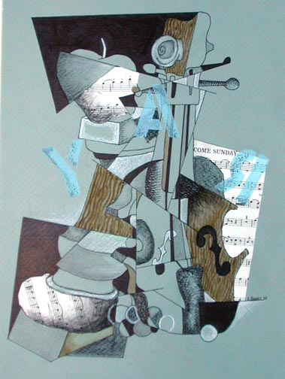
Newsprint
Pencils #2HB, Ebony Black
Rulers
Still life set up (musical instruments work well)
Colored Mat Board scraps (boards cut to approx 12" x 18" (30.5 x 46 cm)
White Conté
Black Charcoal
Watercolor Paint (Burnt Sienna, Raw Sienna, Burnt Umber)
Palettes
Brushes
Graphite Sticks (6B)
Black Felt tip pens (India Ink - optional)
Newspapers/Music sheets
Scissors, Spray Adhesive
Instruction/Motivation:
1. Present the work of Pablo Picasso, Juan Gris and Georges Braque through PowerPoint or slides. Show and discuss segments of video if available. Critique art prints. Set up interesting still life.
2. Demonstrate how to show multiple views of one object - demonstrate fractured planes.
3. Demonstrate collage techniques - demonstrate wood grained textures - review shading

Procedures:
1. After reviewing Picasso and Braque with a video (several titles are available - see resource list) and a text portion of Cubism (Art History), students are set up with a ruler, newsprint, pencil and eraser. Have a group of objects set up in the room for a still life. Ken likes to use the same things Picasso and Braque used such as guitars, wine bottles, fruit, violins, trumpets, etc.
2. With the students around the still life have them begin with a few straight lines on the newsprint, some vertical, some horizontal and some diagonal (about five to start). Talk to them about stylization and simplification of form into to flat shape.
3. When they start to draw these contours of objects, have them start at the top and move down the page. When they get to the lines, shift over and continue to draw the object. Add more lines from parts of the objects that they have started. Have them make at least three studies differing the object used and new lines.
4. Pick out the best design and transfer it to the scrap matt board and this will be the color of the picture.
5. Outline the design with a narrow black pen. Plan out a value pattern using a black felt tip pen.
6. Select at least three areas to collage newspapers or sheet music and use a spray adhesive to glue them down.
7. Use the palette and watercolors to produce a faux wood grain by painting lines, blending with a moistened brush and putting a tone across the area for a light value.
8. Lastly use white and black charcoal pencils and graphite pencils to draw into shapes and make gradations where you like.
Evaluation:
1. Did students show an understanding of cubist style by showing still life from multiple views -
fracturing planes?
2. Did students create interest through value contrast, various textures and collage elements?
2. Did students create a variety of values using both white and black charcoal?

Vocabulary:
Value
Cubism
Collage
Conte Crayon
Gradation

Instructional Tools:
Powerpoint
Artists Picasson, Gris, and Braque

The Old Guitarist, Picasso’s Blue Period 1901-1904
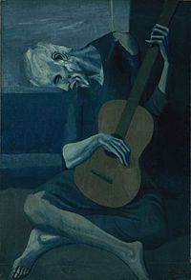

Blue Period
At the time, having renounced his classical and traditional education and searching for fame, Picasso and his friend moved to Paris. Unfortunately, just a year later, the friend became hopelessly miserable from a failed love affair and committed suicide. Picasso was greatly afflicted by this horrible event and was soon depressed and desolate. In addition, Picasso was very poor. His absolute poverty made him identify and relate to beggars, and other downtrodden outcasts in society. In fact, The Old Guitarist is modeled after a blind artist in Madrid.
These events and circumstances led to the creation of Picasso’s Blue Period, which lasted from 1901 to 1904. The Blue Period is identified by the flat expanses of blues, greys, and blacks, melancholy figures lost in contemplation, and a deep and significant tragedy. However, some rumors say that Picasso was so poor he could only afford a canvas and tubes of blue paint. Either way, The Old Guitarist is a painting produced during Picasso’s Blue Period.

Analysis
Every single element in The Old Guitarist was carefully chosen to render a stronger reaction in the audience. For example, the monochromatic color scheme eliminates the joy of changing colors and light and creates flat, two-dimensional forms that dissociate the guitarist from time and place. In addition, the overall muted blue palette creates a general tone of melancholy and accentuates a tragic and sorrowful theme. Also, the sole use of oil on panel causes a darker and more theatrical mood. Oil tends to blend the colors together without losing the colors’ brightness, creating an even more cohesive dramatic composition.^{[2]}
Furthermore, the guitarist shows no sign of life and appears to be close to death, implying little comfort in the world and accentuating the misery of his situation. Details are eliminated and scale is manipulated to create elongated, scrawny, and elegant proportions and to intensify the silent contemplation of the guitarist and a sense of spirituality. Despite the guitarist’s blindness, viewers feel the guitarist holds an inner vision and psyche. Moreover, the large, brown guitar is the only shift in color found in the painting. The guitar fills up the space around the guitarist physically and symbolically. In its dull brown, the guitar becomes so prominent against the blue background that it is the center and focus of the guitarist and the viewer. The guitar comes to represent the guitarist’s world and only hope for survival.
This blind and poor artist depends on his guitar and the small fare he can create from his music for survival. Plus, a guitar, as a musical instrument, is a natural mean for expressing emotions. This allows the guitarist to share and increase his loneliness. Some art historians believe this painting expresses the solitary life of an artist and the natural struggles that come with the career. Therefore, music, or art, becomes a burden and a separating force, isolating artists from the rest of the world. Art in general becomes a symbol of rejection and isolation. ^{[3]} And yet, despite the isolation, the guitarist (artist) depends on the rest of society for survival. All of these latter feelings and emotions reflect Picasso’s predicament at the time, which could easily lead to the conclusion that Picasso was criticizing the state of society. The Old Guitarist becomes an allegory of human existence.

The Three Musicians, Picasso, Cubism, 1908-1917
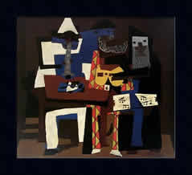

Cubism was developed 1907 - 1912 as a collaborative effort by Pablo Picasso and George Braque. Although its roots are not positively known, many believe it has influence from African Tribal Art and Paul Cezanne. Cubism was considered the most radical change in art in the 20th century. Unlike the previous Picasso Blue Period, its core style was a complete abandonment of traditional art techniques. Instead of looking at subjects at a fixed angle, the artwork was broken into facets where many aspects can be viewed simultaneously.
The art form supported their belief that there was no one fixed view of nature. Picasso and Braque worked hand in hand and were dedicated to simplifying painting, only including formal elements of art: line, shape, and color.

The movement was divided into two periods - Analytical Cubism and Synthetic Cubism. Analytical Cubism concentrated on using geometric forms, often using strait lines and right angles. Subdued colors such as tans, browns, grays, blues and greens were preferred. Overall, it showed a structured "analysis" of form.
Synthetic Cubism, the second period, used more decorative shapes, stencilling, collage, and brighter colors. Pieces of cut-up newspaper and tobacco wrappers could now be found in Picasso and Braque’s paintings. This collage technique posed the question of what was reality vs. illusion.
In addition to Picasso and Braque, many well-known cubism artists started to emerge: Fernand Leger, Jacques Lipchitz, Jean Metzinger, Fritz Wotruba, to name a few. The cubism movement ended by the end of World War I, but we can see direct influences in future art movements such as Futurism, Orphism and Constructivism.

The first reaction to the Three Musicians piece, is that it is a very distinctive style and linear. It puts off an energetic bright feeling. The colors used are very warm with only cool and dark colors used to seemingly describe the characters within. The texture seems very unique and helps with the style of the shapes. The piece is representational and asymmetrical in balance. Colors, texture, lines, spacing, just about all the elements are used in this work to create the mood of this painting. Implied lines are used to help create the images of the people being depicted. It was likely an open palette used, and each color is used to help balance and define the rest of the painting. Warm colors are very dominate in this piece and are very important in the meaning. The positive shapes are three men playing music each with different roles. The negative shapes are surrounding them appearing to be a box or room.

I believe the unity is in the meaning and their actions. There is no distinctive imagery used as unity that I can see. The point of emphasis is the guitar player in the middle. The clothing of the outside characters leads you into the middle where the guitarist is wearing plaid, very colorful clothing. I believe the meaning of this to Picasso is that people of very different walks of life can come together with such a simple idea or action. In this three very different looking characters are enjoying playing music together despite their differences that once may have influenced them to think they had nothing in common at one point. The artist likely thinks of the world as a very unique place with tons of different influences, but similarities across the board no matter who you are. I would think this also depicted his life in some ways and had sentimental meanings of its own to Picasso. The format is easily described because it's during a time when Picasso was into collage style or overlapping images or colors. It came during his Synthetic Cubism stage in his artwork.

This piece is very effective once one really takes time to take apart the elements involved. At first the meaning seems somewhat simple, and then the interpretations begin to soar as you look closer. The painting now means a lot more to me now than my first impression, because I do agree that sometimes we let the little differences divide us as a species. It isn't just about being energetic and having fun, but also about being open to new ideas, styles, or lifestyles.
This is a very well done piece. Its depictions of such a simple hobby as to the meanings provide a very educational piece for many. It also is effective in creating a happy atmosphere although all the images may not be the ideal definition of cheerful. This is a great example of why Picasso was one of the most innovative and impacting artists of the 20th century. He's working on a whole new style and still creates the exact imagery mentally and physically that he aims for.
--Nathan Beaver, Yahoo network coordinator 2006

Picasso’s Painting Periods
Compare and Contrast

After reading the two separate analysis of Picasso’s The Old Guitarist and The Three Musicians, compare and contrast the two different works. How are they similar? How are they different? What are the significances behind each piece? What is your opinion of these works? Complete a 3 paragraph essay on these works and be as thorough as possible (35pts)

Cubism Collage Drawing
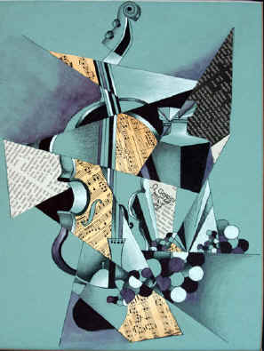
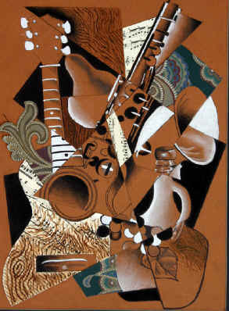
Procedures:
- Set up your drawing paper vertical and choose and instrument to draw, Picasso often used instruments as his subject matter in art
- On your paper, draw 5 to 6 lines dividing the page. Some should be horizontal, vertical and diagonal
  - Start to draw these contours of objects, start at the top and move down the page. When you get to the lines, shift over and continue to draw the object. Add more lines from parts of the objects that you have started.
- Outline all you lines (including the additional ones you drew coming off of your object) with black marker
- Add Value
- 6. Select at least three areas to collage newspapers or sheet music and use a spray adhesive to glue them down.
- 7. Use the palette and watercolors to produce a faux wood grain by painting lines, blending with a moistened brush and putting a tone across the area for a light value.
- 8. Lastly use white and black charcoal pencils and graphite pencils to draw into shapes and make gradations where you like.

When I grade, I am looking for………
1. Did students show an understanding of cubist style by showing still life from multiple views -
fracturing planes?
2. Did students create interest through value contrast, various textures and collage elements?
2. Did students create a variety of values using both white and black charcoal?

