Composition with Hands: Full charcoal rendering
Big Idea: Hands are often the subject matter in fine art
Grade: Art II
Time: 5x 40 min class periods
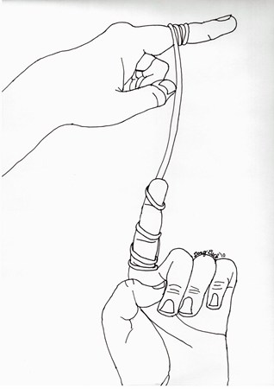
Lesson Overview: Students will practice essential hand drawing techniques as well as explore the artwork of artists who use hands as a subject matter in their work by creating several blind contour and contour line sketches of hands. They will create three drawings, one of contour hands, one of hands composed in sign language, and one of hands tied together with string.

Essential Questions:
How does composition play a role in creating an interesting image?
What is a contour line?
What are some of the challenges for setting up a drawing?
How are colors and patterns used in artworks?

Key Concepts:
Contour line helps to illustrate the main lines of a drawing
Composition is important in creating an interesting work of art
The anatomy of the hand makes drawing difficult but interesting.

PA Standards for Arts and Humanities:
1-G (9 - 12) Students apply media, techniques, and processes with sufficient skill, confidence, and sensitivity that their intentions are carried out in their artworks
9.1.12 C. E. Delineate a unifying theme through the production of a work of art that reflects skills in media processes and techniques.
9.4.12 G G. Analyze works in the arts by referencing the judgments advanced by arts critics as well as one’s own
analysis and critique.

Interdisciplinary PA Standards: History, Anatomy, Science

Objectives:
Knowledge: students will learn about artists that have used hands a subject matter in their works and complete several studies of their own hands.
Skills: Students will use their own hands and review anatomy of hands, how you can create sketches and studies for a work of art, and create one final composition of the design.
Disposition: Students critique their work at separate times during the class to examine their drawing process along the way and to share ideas before the work is finalized.

Procedures:

Introduction: The teacher will introduce the lesson through a power point presentation. Students will use the first class period to work on blind contour sketches and practice what would make an interesting composition for their work.

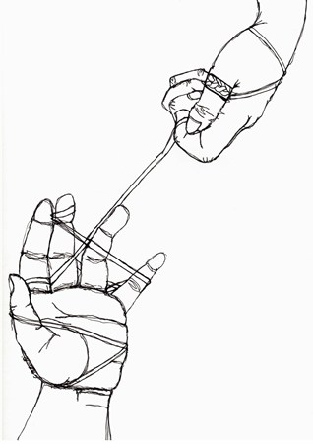
Development: After sketches and preliminary drawings are complete, students will share their ideas as a group briefly to discuss a plan of action to being a large composition. The first composition will be 5 hands, in any arrangement, showing different angles on large white paper. The second composition will be to draw their hands in connection with a piece of string. They must use their imagination to connect the two in order to draw them. The third composition will be to choose three position based upon American Sign Language to create a picture that will have a line pattern in the background as part of their drawing.

Conclusion: At the end of class, students will matte each one of their drawings and display them in a way that shows their transformations. Each student will present their drawings to the class in a critique. They should explain their choices for their drawings and why they chose the object. Students will conclude by completing a self assessment for a grade.

Vocabulary:
Blind contour vs contour
Composition
Rule of thirds
Format
American Sign Language

Materials:
Large paper sizes, pencils, markers, newsprint,
Student handouts

Instructional Tools:
Drawing Dynamic Hands: http://www.amazon.com/gp/product/0823013685?ie=UTF8&tag=incredibleart-20&linkCode=as2&camp=1789&creative=9325&creativeASIN=0823013685
Drawing Real Hands:
http://www.amazon.com/gp/product/0891348174?ie=UTF8&tag=incredibleart-20&linkCode=as2&camp=1789&creative=9325&creativeASIN=0891348174

Resources on hands artists:
http://www.princetonol.com/groups/iad/lessons/middle/hands.htm

Contour Line Hands
Ms. Herman

Hands have been an important part of artist’s studies for drawing. By exploring the anatomy of the human hand through contour line, you will grasp a further understanding of this complex form.
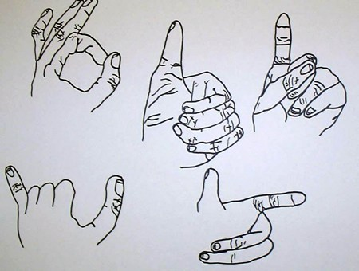
Project 1: Contour hands studies
- Show 5 examples of contour line drawing hands
- Arrange hands in a composition on the paper
- 20pts

Project 2: Contour hands with String
- Choose and arrangement of hands using a string
- Draw your hand once with the string, tension the line, and move your hand to a new position to draw
- 30pts

Project 3: Sign Language Hands
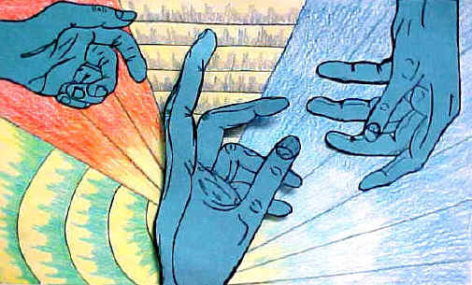
- Choose three poses for hands using the American Sign Language forms
- Must choose up to three different poses for hands
- Using elements of art: COLOR and principles of design: EMPHASIS and RHYTHEM create a pattern of some kind the background to make the contour line hands ‘stand out’ and connect throughout the piece
- 50pts

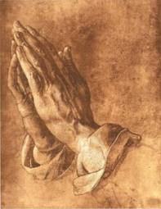
The Praying Hands by Albrect Durer

Back in the fifteenth century, in a tiny village near Nuremberg, lived a family with eighteen children. Eighteen! In order merely to keep food on the table for this mob, the father and head of the household, a goldsmith by profession, worked almost eighteen hours a day at his trade and any other paying chore he could find in the neighborhood.
Despite their seemingly hopeless condition, two of Albrecht Durer the Elder's children had a dream. They both wanted to pursue their talent for art, but they knew full well that their father would never be financially able to send either of them to Nuremberg to study at the Academy.
After many long discussions at night in their crowded bed, the two boys finally worked out a pact. They would toss a coin. The loser would go down into the nearby mines and, with his earnings, support his brother while he attended the academy. Then, when that brother who won the toss completed his studies, in four years, he would support the other brother at the academy, either with sales of his artwork or, if necessary, also by laboring in the mines.
They tossed a coin on a Sunday morning after church. Albrecht Durer won the toss and went off to Nuremberg.
Albert went down into the dangerous mines and, for the next four years, financed his brother, whose work at the academy was almost an immediate sensation. Albrecht's etchings, his woodcuts, and his oils were far better than those of most of his professors, and by the time he graduated, he was beginning to earn considerable fees for his commissioned works.
When the young artist returned to his village, the Durer family held a festive dinner on their lawn to celebrate Albrecht's triumphant homecoming. After a long and memorable meal, punctuated with music and laughter, Albrecht rose from his honored position at the head of the table to drink a toast to his beloved brother for the years of sacrifice that had enabled Albrecht to fulfill his ambition. His closing words were, "And now, Albert, blessed brother of mine, now it is your turn. Now you can go to Nuremberg to pursue your dream, and I will take care of you."
All heads turned in eager expectation to the far end of the table where Albert sat, tears streaming down his pale face, shaking his lowered head from side to side while he sobbed and repeated, over and over, "No ...no ...no ...no."
Finally, Albert rose and wiped the tears from his cheeks. He glanced down the long table at the faces he loved, and then, holding his hands close to his right cheek, he said softly, "No, brother. I cannot go to Nuremberg. It is too late for me. Look ... look what four years in the mines have done to my hands! The bones in every finger have been smashed at least once, and lately I have been suffering from arthritis so badly in my right hand that I cannot even hold a glass to return your toast, much less make delicate lines on parchment or canvas with a pen or a brush. No, brother ... for me it is too late."
More than 450 years have passed. By now, Albrecht Durer's hundreds of masterful portraits, pen and silver-point sketches, watercolors, charcoals, woodcuts, and copper engravings hang in every great museum in the world, but the odds are great that you, like most people, are familiar with only one of Albrecht Durer's works. More than merely being familiar with it, you very well may have a reproduction hanging in your home or office.
One day, to pay homage to Albert for all that he had sacrificed, Albrecht Durer painstakingly drew his brother's abused hands with palms together and thin fingers stretched skyward. He called his powerful drawing simply "Hands," but the entire world almost immediately opened their hearts to his great masterpiece and renamed his tribute of love "The Praying Hands."
~Source Unknown~

Answer the following questions on a separate piece of paper

- What are the big ideas of this story?
- What is the nature of the brother’s agreement? Do you think it was fair?
- What does this story illustrate about human nature?

