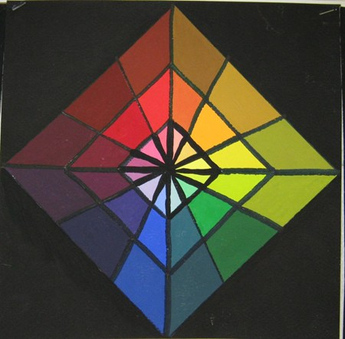
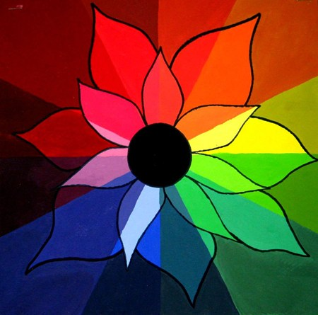

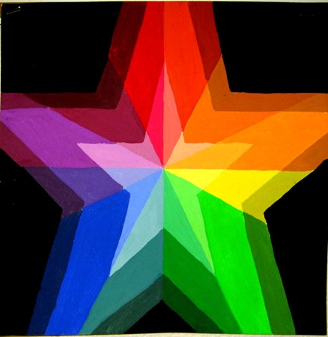
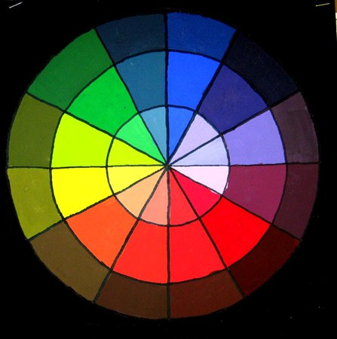
Color Wheel
The color wheel is the primary device used by artists to create mixtures of paint. This is much like cooking class—there is a specific recipe to create each color. In this assignment you will…..
- Create Values (Adding white to a color or HUE)
- Create Secondary colors from Primary colors
- Create intermediate colors
- Learn the difference between TONES (adding white) and SHADES (adding black)

What I am looking for…..
- Proper paint storage and clean up
- Effective color wheel design out of pencil
- Proper mixing of tones, shades and intermediate colors
- Craftsmanship and Participation.

