Coffee Painting

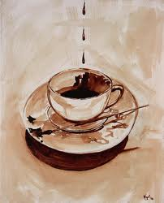
Not all painting has to be done with actual ‘paint’, alternative materials are out there! Early artists and paints where made from all natural elements found outside unlike the synthetic paint we use today. You will have a chance with this lesson to create your very own ‘coffee painting’. You will use diluted coffee to create your painting much like a watercolor.

Choose your subject matter wisely. No lettering, or lucky charms of the art room. You can create a design, pattern, animal, landscape, or scene of your choosing. (maybe even a cup of joe?)

Step 1

- Do a line drawing using regular pencil, drawing lightly so that you can easily erase. take your time during this step.
- Draw in all the details...
- The better your drawing is, the better your finished painting will be.
- Do not create values (do not shade!!!)

- Show darks and lights by drawing them as shapes without shading them in. You can also show different colors the same way. Draw the different colored shapes, but don't shade them in.

Step 3

- Trace over all of your pencil lines with a Fine Line black Sharpie marker. During this step, you will also stylize all of your lines and shapes (round all the corners).

- Show me the project before the next step.
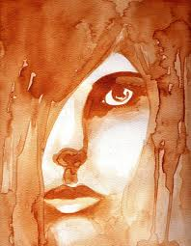
Step 4

- Paint the piece using coffee.

- You will dilute instant coffee granules into water to create a "wash". You will use the wash to paint the variety of values. Follow the darks and lights in the tile as accurately as possible, translating these values into browns and sepia tones using coffee as your "paint".

- Shapes touching each other should not be the same brown value.
- Trace your design with a Sharpie again.

Don't lick your painting !!!!!

