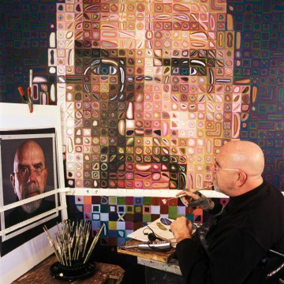
Chuck Close Self Portrait

Charles Thomas "Chuck" Close (born July 5, 1940,] is an American painter and photographer who achieved fame as a photorealist, through his massive-scale portraits. Though a catastrophic spinal artery collapse in 1988 left him severely paralyzed, he has continued to paint and produce work that remains sought after by museums and collectors.

You will create a self portrait in a similar style to Chuck Close. After his accident, Close came up with a new idea to help him adapt his painting technique. By taping a paint brush to an arm splint, Close used a coordinate system to create his portraits as well. You will create a coordinate system as well to enlarge your photo we took in class.

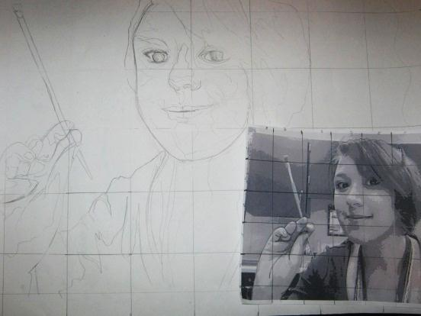
Steps to create your painting:

- Grid the inked portion of your photograph only. The Grid should be 1 ½ by 1 ½ inches from right to left. You must draw straight lines.
- Grid your large paper 3” by 3 “
- Draw your portrait one square at a time. Concentrate on drawing the outside, contour lines to start then draw all the lines isolating your shadows in your picture.
- Erase all of the grid lines. Leave the areas that do not have any drawing.
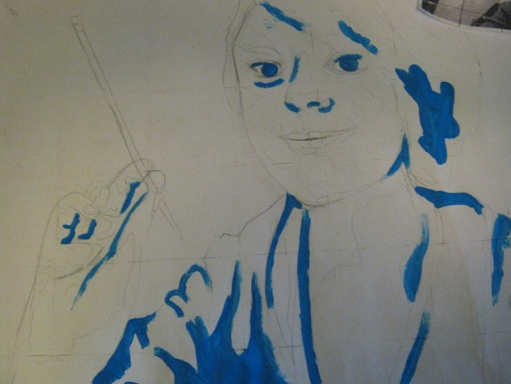
- In an egg carton, mix 3 tints, one pure hue, and one shade. Paint your drawing following the same tints and shades in your photograph. Where you have a dark grey, use a shade, wherever a light gray use a tint. Fill in your background with a gradient from dark to light around the edges.
