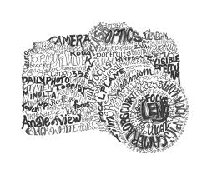

What is a Calligram?
A calligram is a poem, phrase, or word in which the typeface, calligraphy or handwriting is arranged in a way that creates a visual image. The image created by the words expresses visually what the word, or words, say. In a poem, it manifests visually the theme presented by the text of the poem.
Process:
- Choose a poem, song lyrics, or a series of synonyms for your calligram (make sure it is school appropriate, no innuendos).
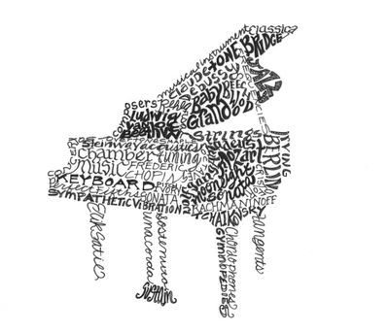
- Create a light sketch of a silhouette of the drawing you want to fill with your calligram. Try to draw off where you want to add certain values
- Sketch in your text and fill with sharpie marker
- Erase all excess pencil and matte your artwork

