[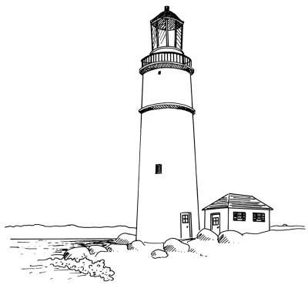](http://adventure.howstuffworks.com/lighthouse-pictures.htm)

[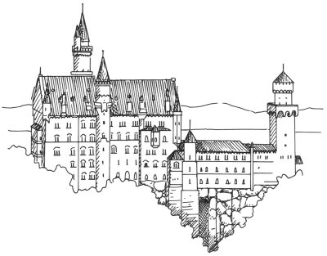](http://home.howstuffworks.com/home-improvement/awesome-architecture-pictures.htm)

[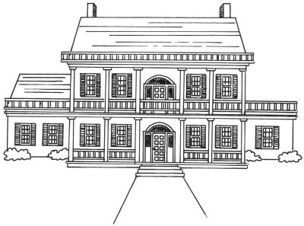](http://home.howstuffworks.com/home-design-pictures.htm)

[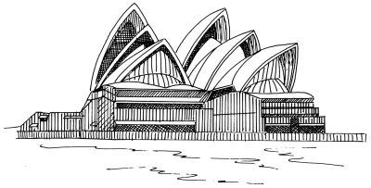](http://adventure.howstuffworks.com/landmark-pictures.htm)

[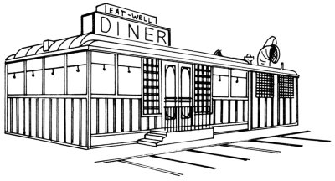](http://home.howstuffworks.com/enlarge-image.htm?terms=Architecture&gallery=1&page=0)

[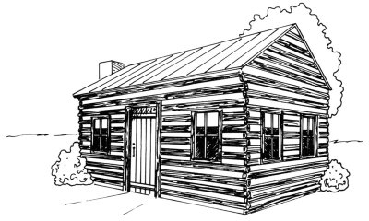](http://home.howstuffworks.com/home-design-pictures.htm)

[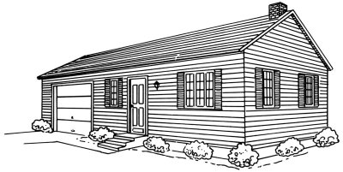](http://home.howstuffworks.com/home-design-pictures.htm)

[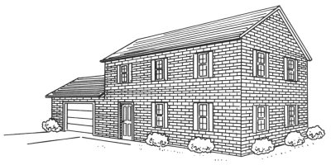](http://home.howstuffworks.com/home-design-pictures.htm)

[](http://adventure.howstuffworks.com/landmark-pictures.htm)

[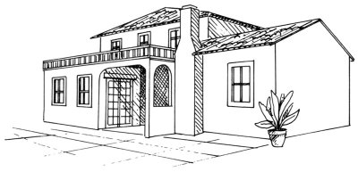](http://home.howstuffworks.com/home-design-pictures.htm)

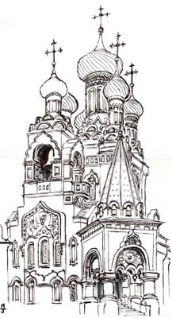

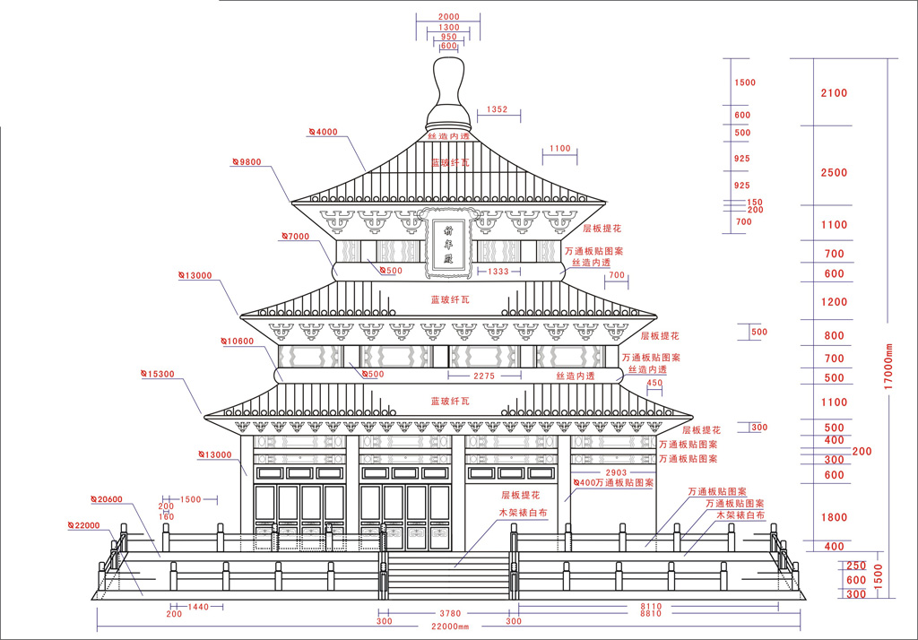

[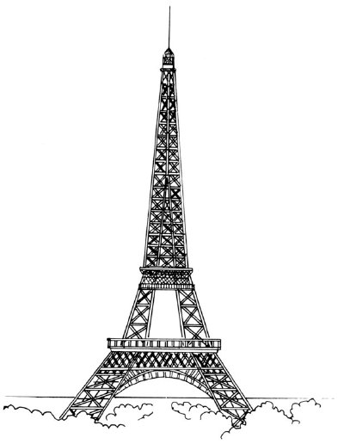](http://adventure.howstuffworks.com/landmark-pictures.htm)

[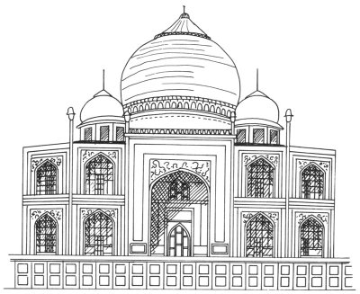](http://adventure.howstuffworks.com/landmark-pictures.htm)