Book Sculpture Lesson
Kelly Herman
Art I

Lesson Overview: Students will research a new kind of sculpture art...upcycled book folding. Students will research a technique for folding a book and then create their own sculpture based on this inspiration. Students will then create a typed disposition paper based on their sculpture and their reaction to changing a book.

Knowledge: Basic web searching techniques as well as concepts of 3D design
Skills: Students will exhibit higher order thinking strategies on how to convert something flat into 3 dimensions.
Dispositions: Students will create an artist statement based on their reaction to their sculpture and upcyling a book.

Essential Questions:
    - How can the book pages be folded to create a 3D sculpture?
    - How does the nature of the book change by folding the pages?
    - Did you have any conflict doing this project to the books?
      - What was the emotional trigger?
    - How are books viewed in todays society? Are they important or obsolete? How have books changed over time?
Vocabulary:
Upcycled Art, recycled art
Origami
Disposition
Non-form shape

Keystone Standards: Students will practice writing a disposition by creating an Artist statement

PA Standards for the Arts and Humanities:

9.1.12.K: Analyze and evaluate the use of traditional and contemporary technologies in furthering knowledge and understanding in the humanities.

9.4.12.A: Evaluate an individual’s philosophical statement on a work in the arts and its relationship to one’s own life based on knowledge and experience.

Procedures:

Introduction: Students will research book folding strategies, the history of text, as well as gather information on how books have changed over time

Production: Using one of the book folding techniques researched, students will create their own book sculpture using folding techniques

Culmination: Students will write a disposition on their artwork to go along with the display.

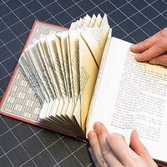
Book Sculpture Research: The Ideation Process

Before sculpture artists begin a work, they always conduct research first. Consider this like creating sketches for a still life study. Follow the websites below to artist that work with book sculpture. Answer the questions pertaining to what you find on each website. If you find a sculpture or shape that interests you, save the image in word and print the page. You can use this image to create your own sculpture.

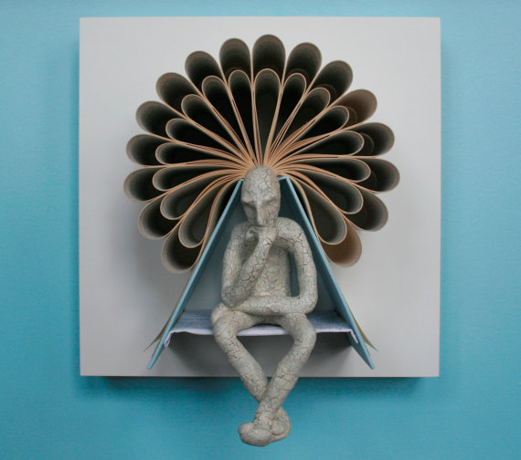

Search the following Book Artists:
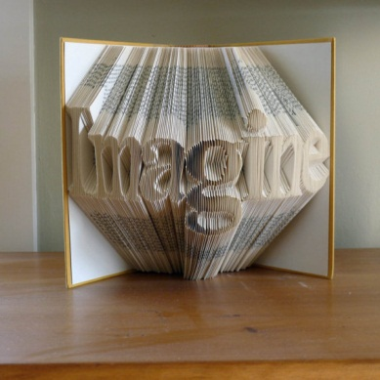
Isaac G. Salazar

Lucille Moroni

Denise Keggan

Michael Bom

Daniel Lai

And Websites:

Etsy.com…search folded page art

http://www.refabdiaries.com/2012/01/book-folding-free-patterns.html: Online Blog

Online Tutorial: http://awhimsywillow.blogspot.com/2012/03/book-art-tutorial.html

Youtube tutorial: http://www.youtube.com/watch?v=g_Wak_soIc0&feature=related

Another Youtube tutorial: http://www.youtube.com/watch?v=3Gg3d7HJisc

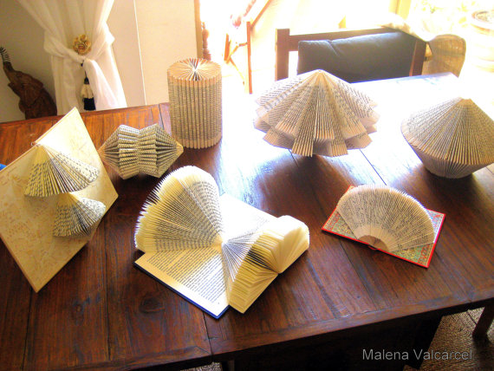
In your research, find a pattern or shape that you would like to try to recreate or invent your own. I want to encourage you to try to make your own…because its easier than trying to copy something or someone else’s work if you have nothing to compare it too! Be original, but it does help to have a reference. Make sure you have looked at all of the links and done your own research before you begin your own.

Artist Statement: A Disposition About Your Book Project
Ms. Herman: Art 1

Artists will sometimes create a narrative or story about their artwork to explain it to the viewer. An artist statement will talk about the process, the material, the vision, inspiration, and what the artwork means or represents to them. You will compose an Artist Disposition about your book. I want your artist statement to be formal, typed, and read as if you had to explain your process to your viewer. Pretend you are having a conversation with a group of people who were looking at your artwork in a famous museum!

You may add anything about your work that you would like to say in your statement, but please also answer the following questions….

- How did you create your idea? Who was the artist behind your inspiration?
- What did you do to each page to create your sculpture? Describe the process?
- What was your final result?
- How did you feel about changing the book? Did it bother or your excite you to fold the pages?
- How have books changed over time? What will happen to books in the future? Is it still important to have books, and why or why not?

This statement will be typed and submitted with your project. Prepare a rough draft and we will type the statement in class to display along with your book sculpture.
