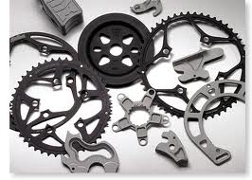
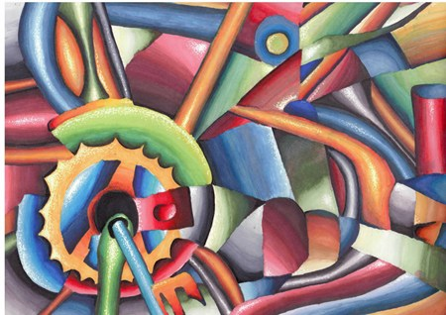
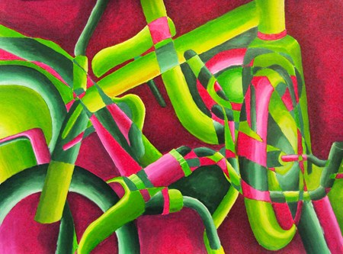

Fractured Bicycle Paintings
To practice using your right brain, and your creativity, you will create an abstract work of art by creating a fractured bicycle painting. Using Complementary colors or Split complementary colors, you can create an interesting composition to compose your painting.
- Draw a sketch of your painting on newsprint. Divide your composition into several sections and draw a different component of the bike in each section.
- Re-draw you sketch onto you’re a piece of canvas board
- Paint your picture with a mix of tints and shades to bring parts of you bike forward or backward in space. Choose split complementary colors or complementary colors.
- Complementary colors are colors that are opposite from each other on the color wheel
- Add small final touches to your piece.
- Spray with gloss medium

Bike Painting Lesson
Kelly Herman Art II

Lesson Overview: Students will explore the cubism process by breaking apart a bicycle and creating an abstract painting using complementary colors.
Objectives:
Knowledge: history of cubism and the use of creating a fractured artwork
Skills: Creative drawing process and use of paint under glazing and over painting
Dispositions: What choices in gradation and value help to emphasize the composition

Procedures:
Day 1. Set up still life and have students divided a canvas board with 5 diagonals. In each section students should draw and enlargement of the bike. When finished, students can add parts of the bike frame and the bike chain to keep try to unify each area.
Day 2-3: Students will practice painting by creating a value change with complementary colors on a piece of newsprint, as well as a gradation on a piece with those same complementary colors. This will be collected and graded
Choosing one complementary color scheme, students will create a light wash of acrylic paint on their canvas. The complementary colors should alternate between bike and background.
Day 3-6: Refering to the value and gradient sheet, students will create an over painting using the change from light to dark in their piece. They should start dark along all the edges of their bikes and light as they move across the object. The ending result should add highlights and lowlights. When the painting is finished students will apply a coat of clear varnish.

PA Standards
9.1.12.B: Recognize, know, use and demonstrate a variety of appropriate arts elements and principles to produce, review and revise original works in the arts.
9.1.12.H: Incorporate the effective and safe use of materials, equipment and tools into the production of works in the arts at work and performance spaces.

Vocabulary:
Gradation, Value, Fracture, abstract, Underglaze, over painting, varnish
Materials:
Canvas board, bikes, pencils, rulers, newsprint, pallets, paints, burshes, cups, water, varnish

