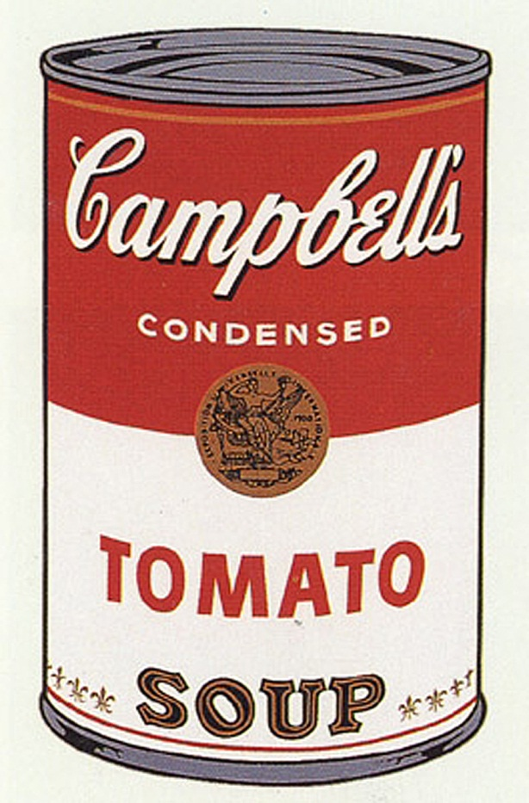
Andy Warhol Linocut
Art II

About the Art:
Warhol's Campbell's Soup Can paintings are key works of the 1960s Pop Art movement, a time when many artists made work derived from popular culture. Warhol's soup cans raise the simply popular or everyday to the status of art. Campbell's and its red and white label date from the late nineteenth century, and became more and more familiar in the twentieth, particularly with the increase in mass production and advertising after World War II. Warhol himself said, "Pop art is about liking things," and claimed that he ate Campbell's soup every day for 20 years. For him, it was the quintessential American product: he marveled that the soup always tasted the same, like Coca-Cola, whether consumed by prince or pauper.

Points of View:
“I used to drink it [Campbell’s Soup]. I used to have the same lunch every day, for twenty years, I guess, the same thing over and over again.”
Andy Warhol
The Campbell's Soup Can series makes me laugh. In this particular piece I want to know whom the brat was that ripped the label. The simplicity of Warhol's work frustrates me. The Campbell's Soup Can painting conjures up the same emotions as a paper clip or a post-it note: "Why didn't I think of that?" Lifting a soup can up to the level of art doesn't put Warhol in league with Raphael, but it does show some Thomas Edison-style ingenuity. The Campbell's series confirms that if Warhol had but one virtue it was awareness. We are all bombarded by popular culture and Warhol was able to recognize that overwhelming influence. He took a soup can, an image recognized by all, and elevated it to the level of art. I'd call him the All-American artist because he made his medium accessible to people of every class and race. The bright color and provocatively bland subject of the Campbell’s series make room for disagreement among the College educated as much as high school dropouts.
Tom Laskow, CAPA High School student, Youth Label Project,
Youth Invasion, The Andy Warhol Museum, 2004.
Soup as the humble meal celebrated by Daumier; soup as the melting pot in an increasingly homogenized America; soup as transition from homemade to pre-prepared item; soup as "good" or "bad" taste, both on the tongue, and as advertising design. Peeling back the label to reveal a generic shape of the machine age generates food for thought: who tracked its route down the assembly line? Who are the tastemakers who determined the flavors of its contents, defining good and bad in terms of sales potential? What were the mechanisms involved in its delivery? Why would Warhol claim that he ate it every day?

Your Printmaking: In the inspiration of Andy Warhol, you will create a Pop Art artwork inspired by a similar name brand product…CANDY! You will choose a candy of your choosing, create sketch, and transfer the design onto your block
WARNING: Make sure your print is BACKWARDS on your block…if not it will print in reverse and all your letters (and your hard work) will be backwards.

What I expect….to earn an A you must:
- Follow safe procedures for cutting linocut (blade away, always on the cutting board, little gouges)
- A complete design, large, that fills the space of your print. All correct areas are cut away
- 6 well pulled prints, matted, of any color variety.
Examples of Linocut Prints…
