Harvest Weaving

You will create a weaving drawing from two exact drawings. By cutting apart each section and placing them together, you will once again create a complete image.

1. Create a contour line drawing of your still life. Nothing should be directly in the middle. Transfer this drawing to one sheet of white and one sheet of colored paper.
2. On your white paper, shade your drawing with an Ebony pencil. Each area should have its own textures and values conveyed with shading techniques
3. One the colored paper, apply both oil pastels and soft pastels. Oil pastels can be used to make interesting texture and soft pastels blend smooth.

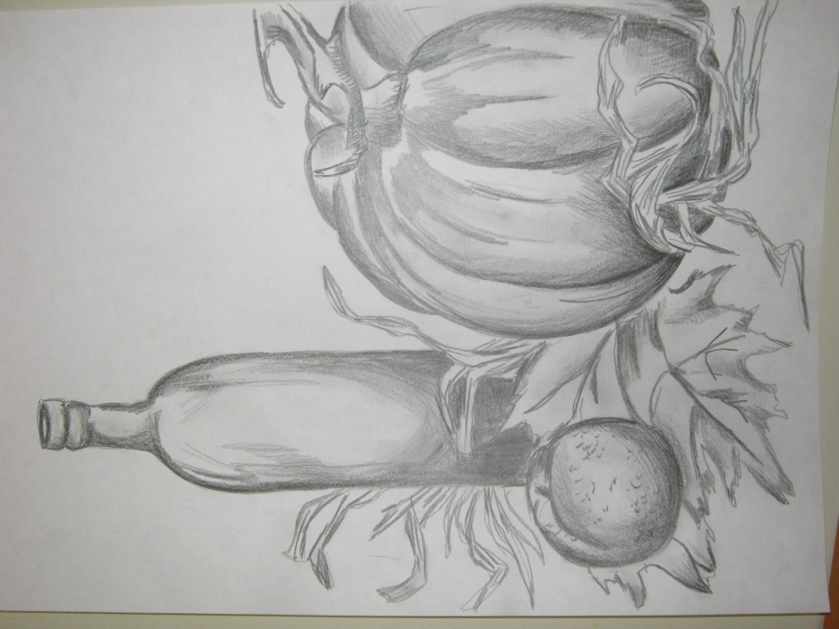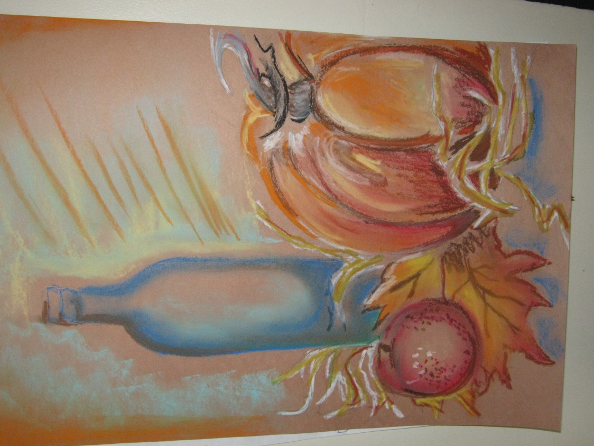

4. Once both drawings are finished, flip each onto the back and grid with 3” by 3” squares

5. Cut one piece horizontally and one piece vertically. They must be different or you cannot weave your papers together.

6. Practice weaving your strips so that each piece goes over-under-over-under and glue.

7. Make sure all ends are glued down and spray with a fixative.

