3D Chess Board: 2 Point Perspectives
Surrealist Enviornment
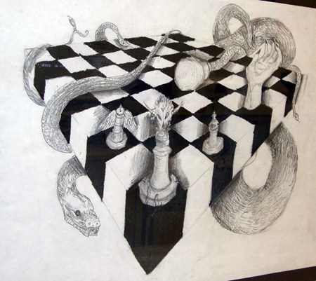
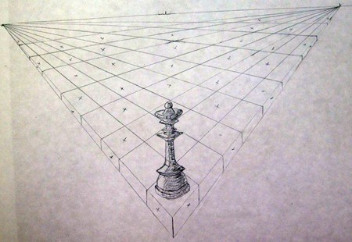

With the use of perspective, you can create three dimensional looking shapes on a flat piece of paper. You will be graded on the following:
- Use two point perspective to create a giant chess board on a piece of drawing paper. (directions on the back). Place a small “x” in each grid where you want to shade black with colored pencil.
- One a piece of newsprint, design 4 different chess pieces as well as an environment pertaining to one theme.
- Add your chess piece ideas to your chessboard and shade with colored pencil.
- Draw at least 5 pieces on the chessboard.
- Create an environment for the background of your chessboard. This should relate to the theme of your actual chess pieces.
- Use crayon and watercolor in your background.
Salvador Dali “The Persistence of Memory” 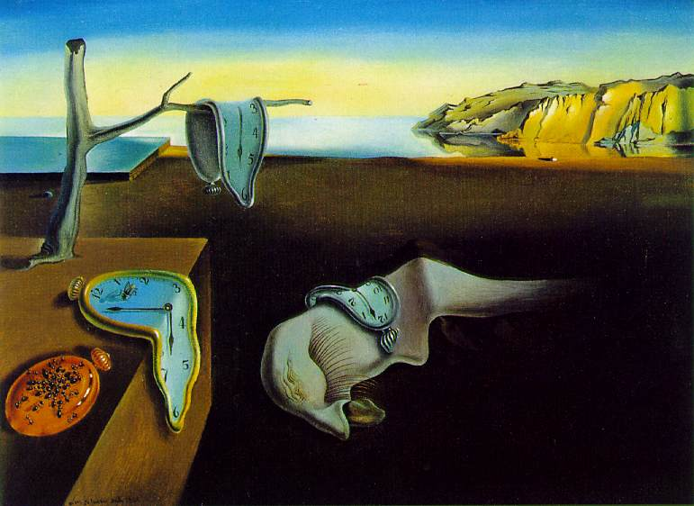
Surrealism: A style of art depicting a dreamlike state. Not to be confused with abstraction, surrealism takes the weird, whimsical use of space, imagery, color, and form to create works of art that depict a dream.
Salvador Dali, a Spanish born artists, became the forefront of the surrealist movement. His paintings depicted deep, unusual ideas including concepts about the human physiological condition. Desires, likes, fantasies, and fears can be interoperated in his paintings.
Moving toward the modern age, Dali became the figurehead of the movement. He was a celebrity, helped create fashion, furniture, architecture the chupa chup candy logo, and even an Alfred Hidgcock scene and Walt Disney movie short.
